**Task on CloudFront**

**1) Configure VPC peering in cross regions.**

Create VPCs in Both Regions

- Sign in to the AWS Management Console.

- Navigate to VPC service.

- Create a VPC in North Virginia (us-east-1):

- Name: VPC-NVirginia

- CIDR Block: 192.168.0.0/24

- Create a VPC in Ohio (us-east-2):

- Name: VPC-Ohio

- CIDR Block: 172.31.0.0/16

Step 2: Create VPC Peering Connection

- Go to VPC Peering Connections in the AWS Console.

- Click Create Peering Connection.

- Enter:

- Name: NVirginia-Ohio-Peering

- Requester VPC: VPC-NVirginia

- Accepter VPC: VPC-Ohio

- Region: Select Another Region (us-east-2).

- Click Create Peering Connection.

- Accept the peering request in Ohio (us-east-2):

- Navigate to VPC Peering Connections in Ohio.

- Select the request and click Accept.

pcx-00abb237ca6d7d4d9

Update Route Tables

- Go to Route Tables in North Virginia (us-east-1).

- Select the route table associated with VPC-NVirginia.

- Add a new route:

- Destination: 172.31.0.0/16

- Target: Select the VPC Peering Connection (NVirginia-Ohio-Peering).

- Repeat the process for Ohio (us-east-2):

- Destination: 192.168.0.0/24

- Target: Select the VPC Peering Connection.

Update Security Groups

- Go to Security Groups in both regions.

- Allow inbound traffic for:

- Protocol: All Traffic or specific ports (SSH - 22, HTTP - 80, etc.).

- Source: 172.31.0.0/16 (for Ohio) and 192.168.0.0/24 (for North Virginia).

Test Connectivity

- Launch EC2 instances in both VPCs.

- Try pinging or SSH between instances using private IPs.

- If connectivity fails, check:

- Route tables.

- Security group rules.

- Peering connection status.

N.virginia-Public Ec2-instance

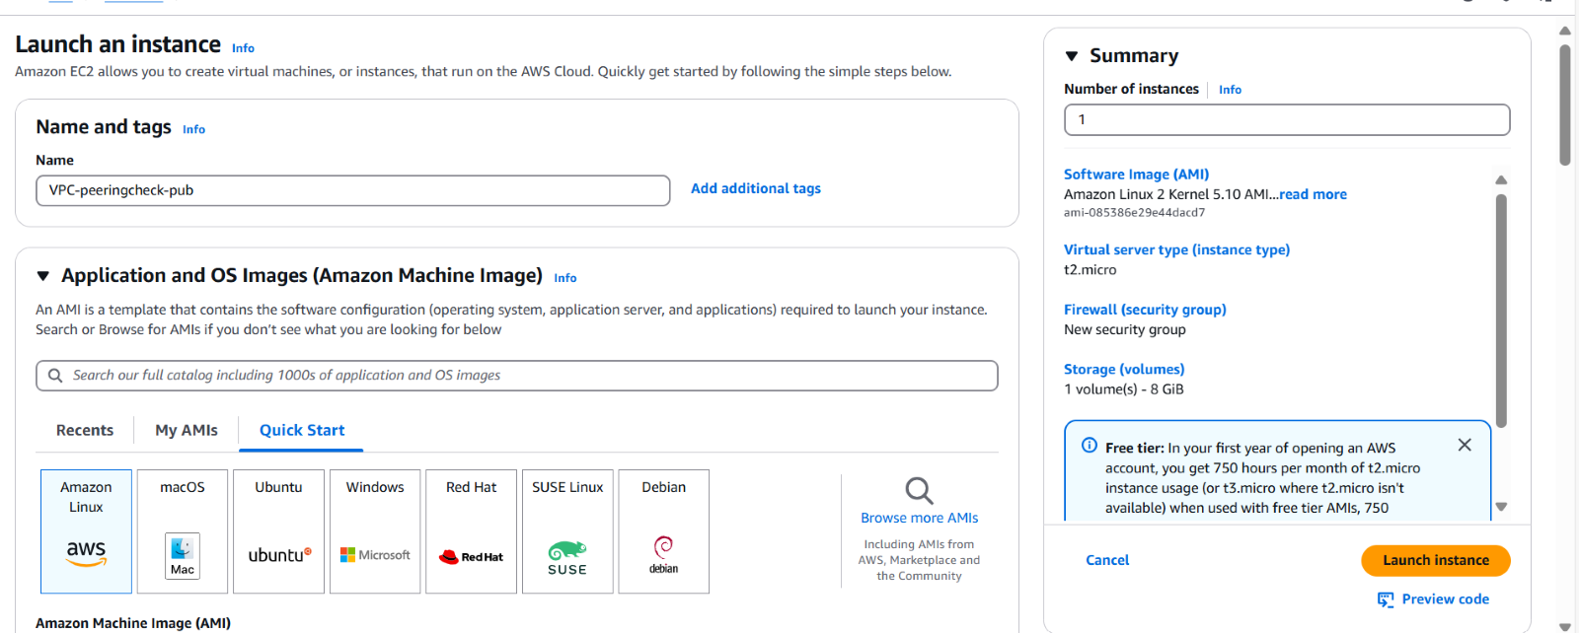

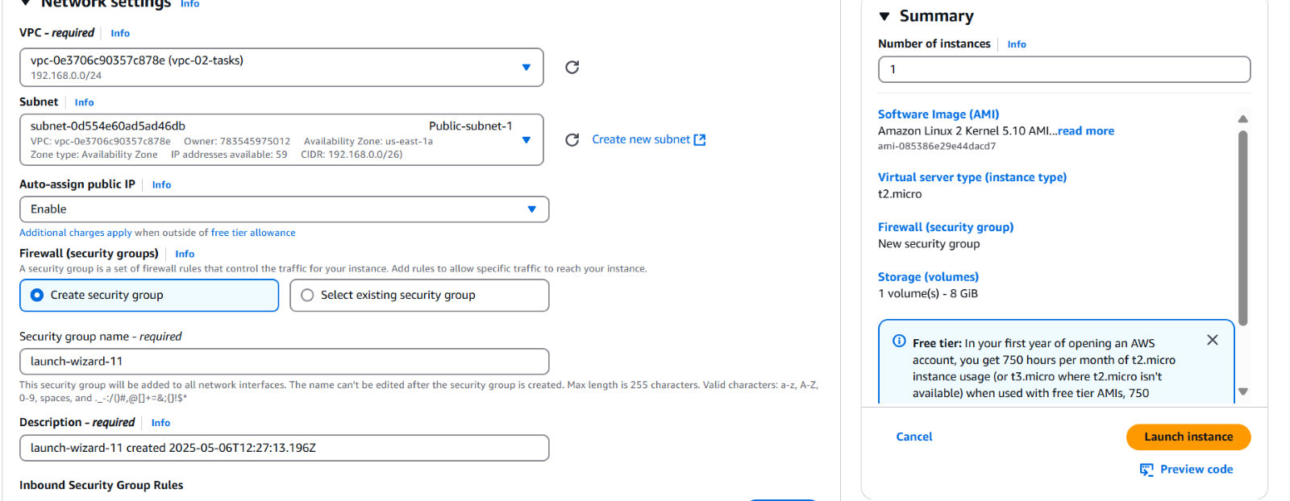

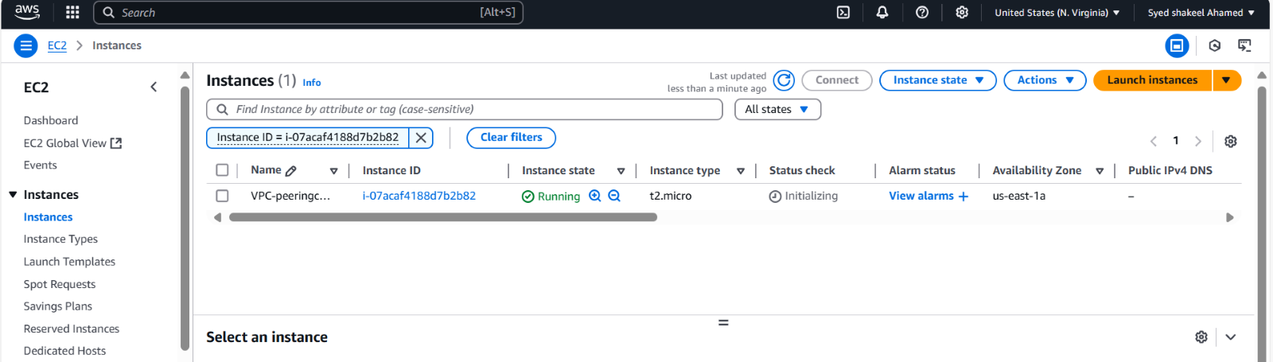

Ohio-Ec2 instance

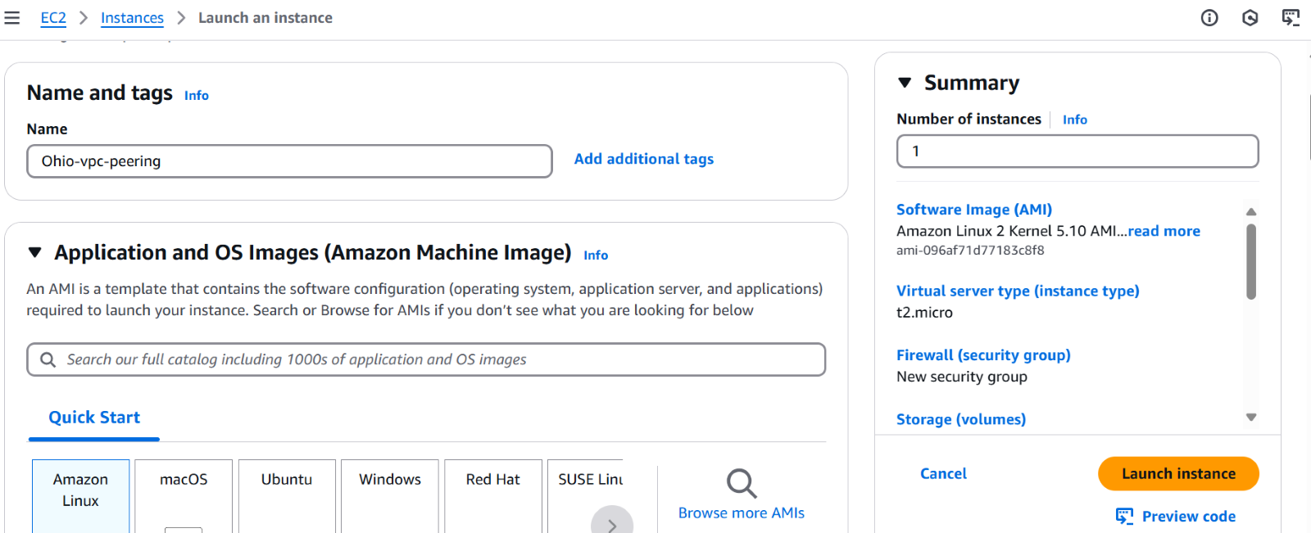

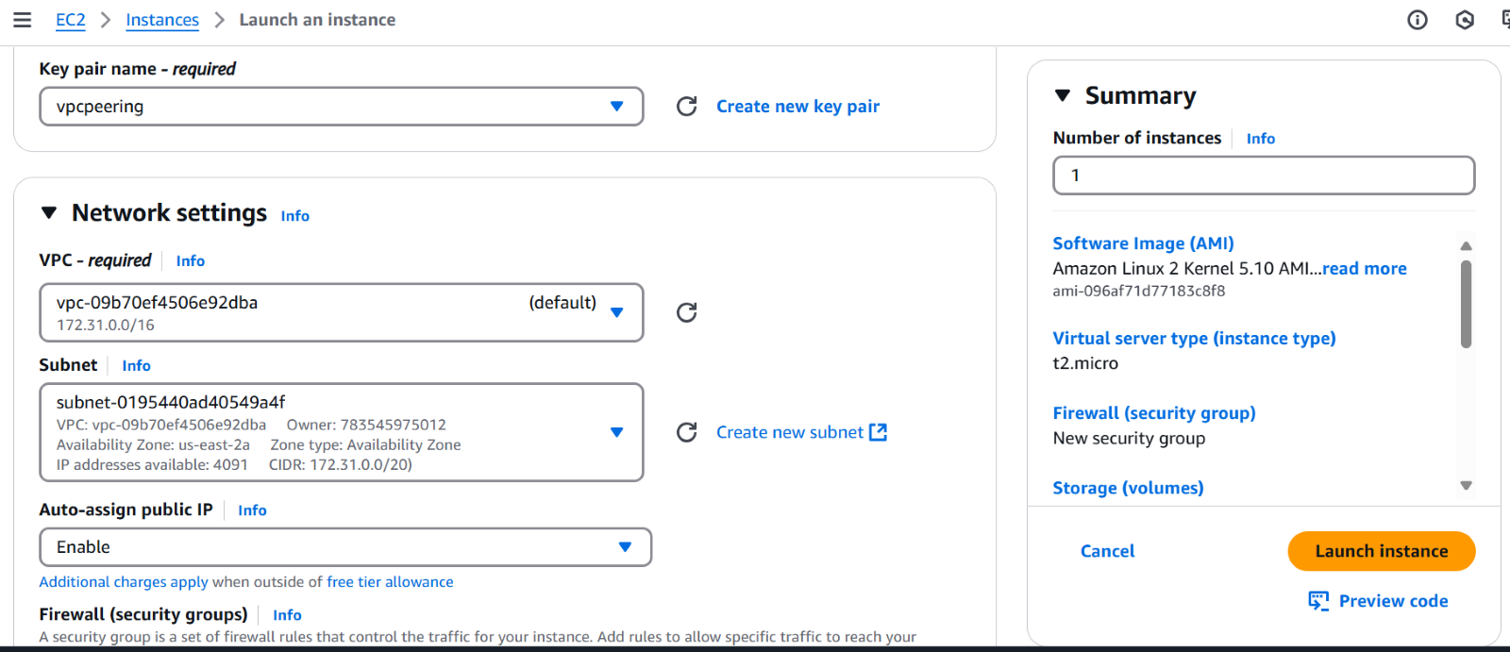

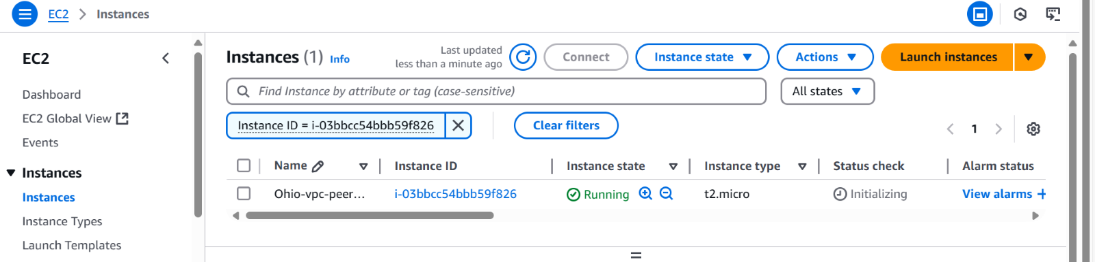

VPC-Peering

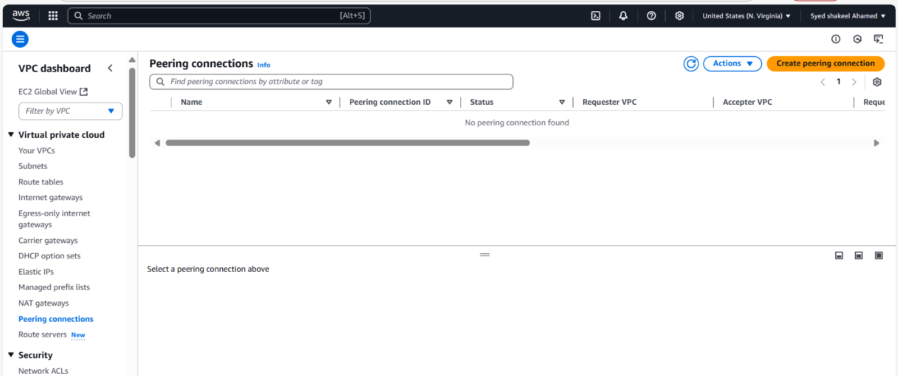

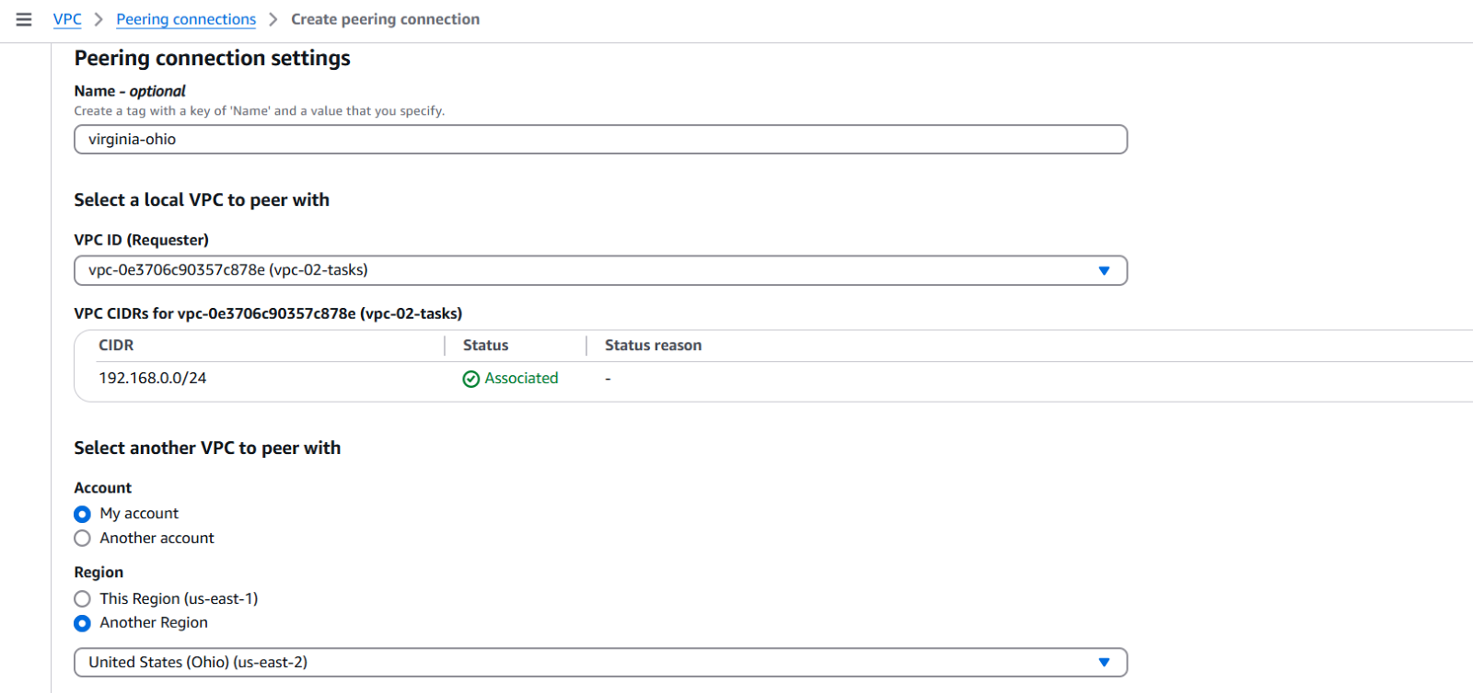

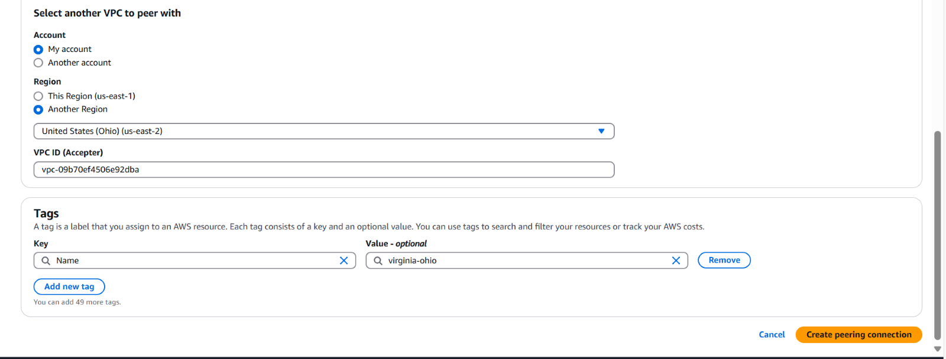

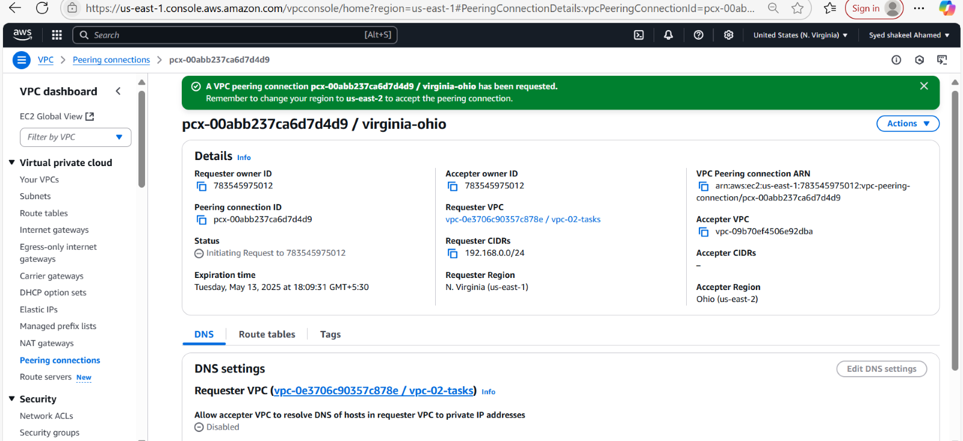

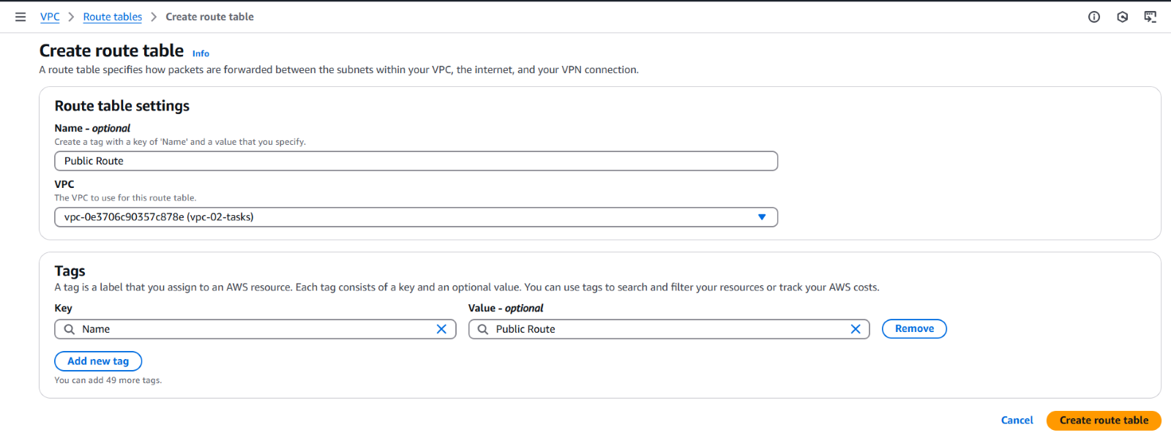

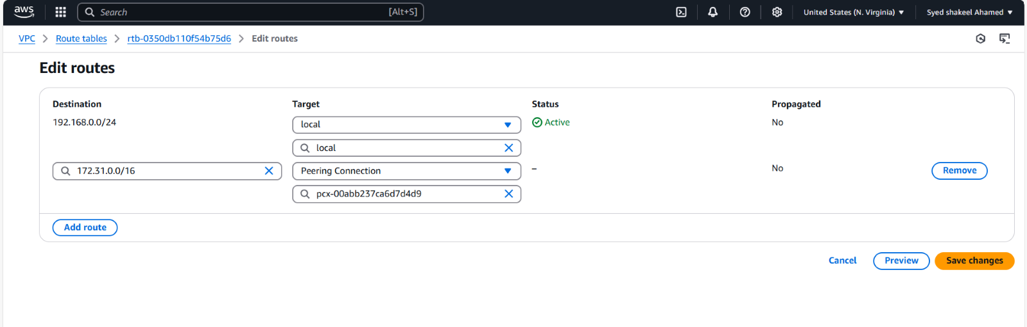

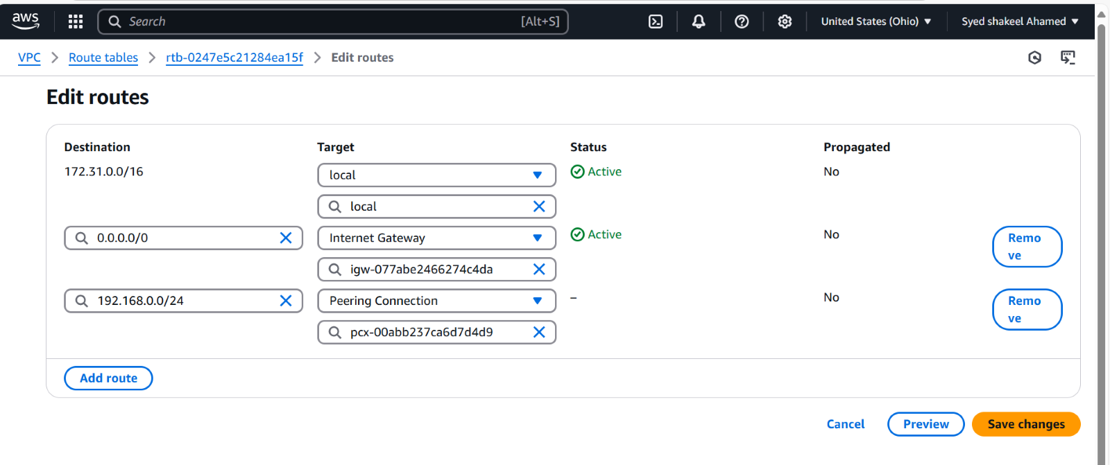

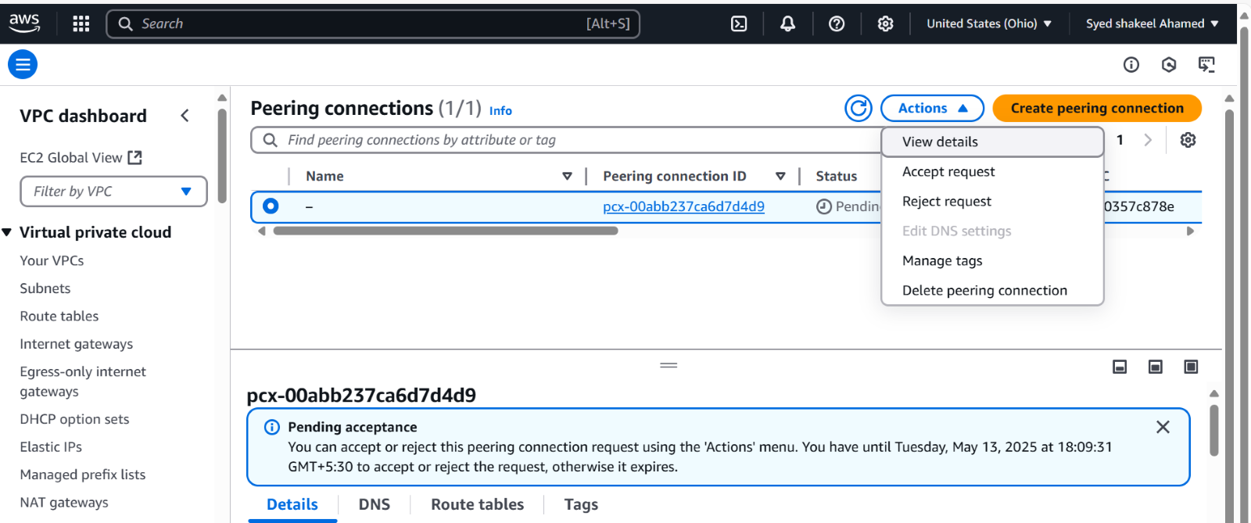

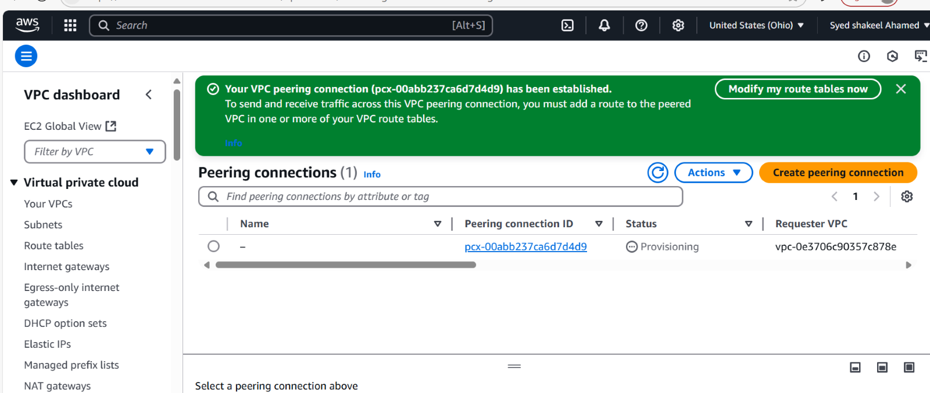

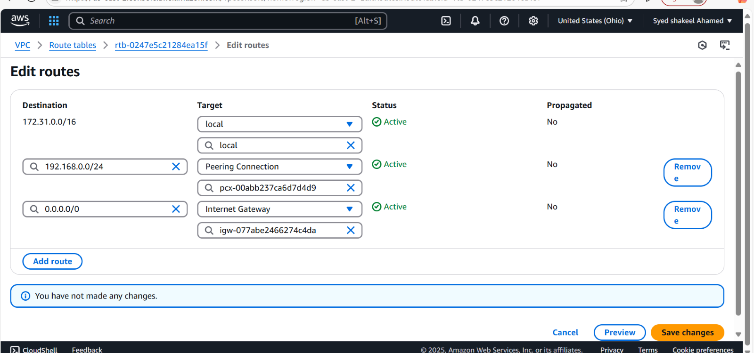

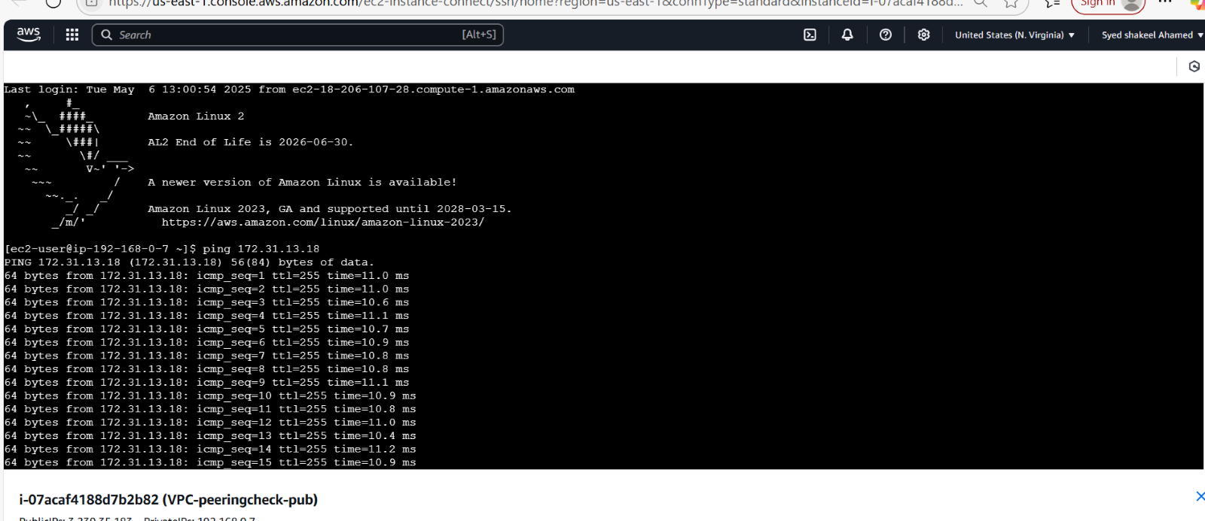

**2) Purchase one domain from GoDaddy**

Visit GoDaddy

- Open your web browser and go to GoDaddy’s website.

- Click on Domains → Search for a domain.

Search for Your Desired Domain

- Enter the domain name you want (e.g., syedawsdevops.shop).

- Click Search to check availability.

- If your domain is taken, GoDaddy will suggest alternatives.

- Choose an available domain and click Add to Cart.

Choose Domain Add-ons (Optional)

- Privacy Protection: Hides your personal details from WHOIS lookup.

- Email & Hosting: You can bundle domain with email or web hosting.

- Multi-Year Registration: Select how many years you want to register the domain.

Create or Log in to Your GoDaddy Account

- If you’re new, click Create Account and enter your details.

- If you already have an account, log in.

Complete Payment

- Choose a payment method (Credit/Debit Card, PayPal, UPI, Net Banking).

- Review your order and click Complete Purchase.

- You’ll receive a confirmation email once the domain is registered.

Configure Your Domain

- Go to GoDaddy Dashboard → My Domains.

- Click on your domain and set up DNS records (A, CNAME, MX).

- If using AWS Route 53, update Name Servers to match AWS settings.

Your domain is now registered and ready to use! 🚀

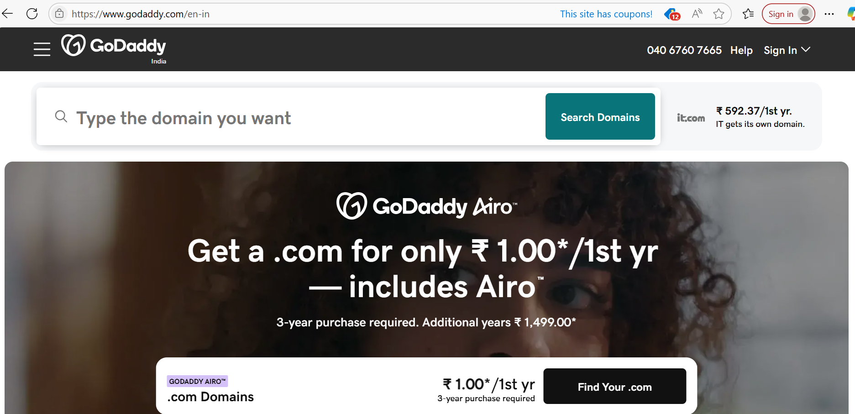

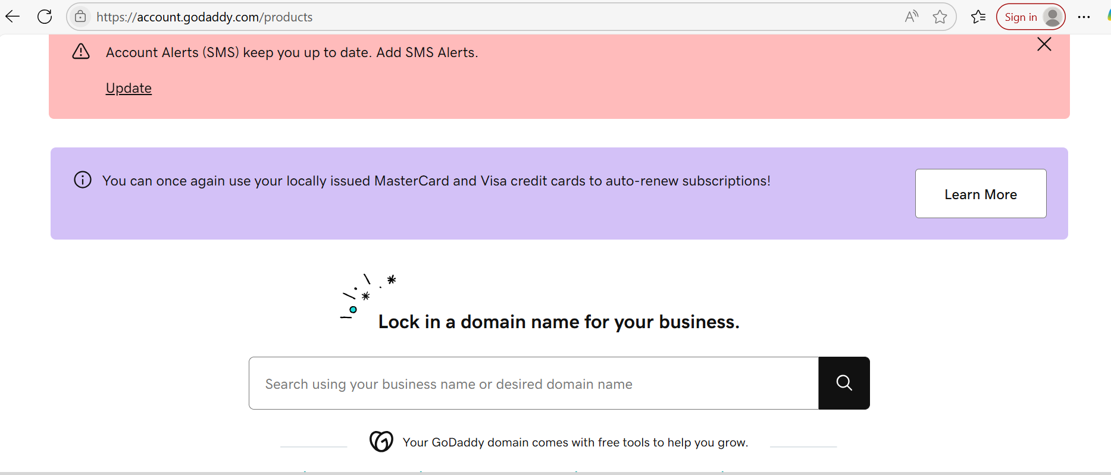

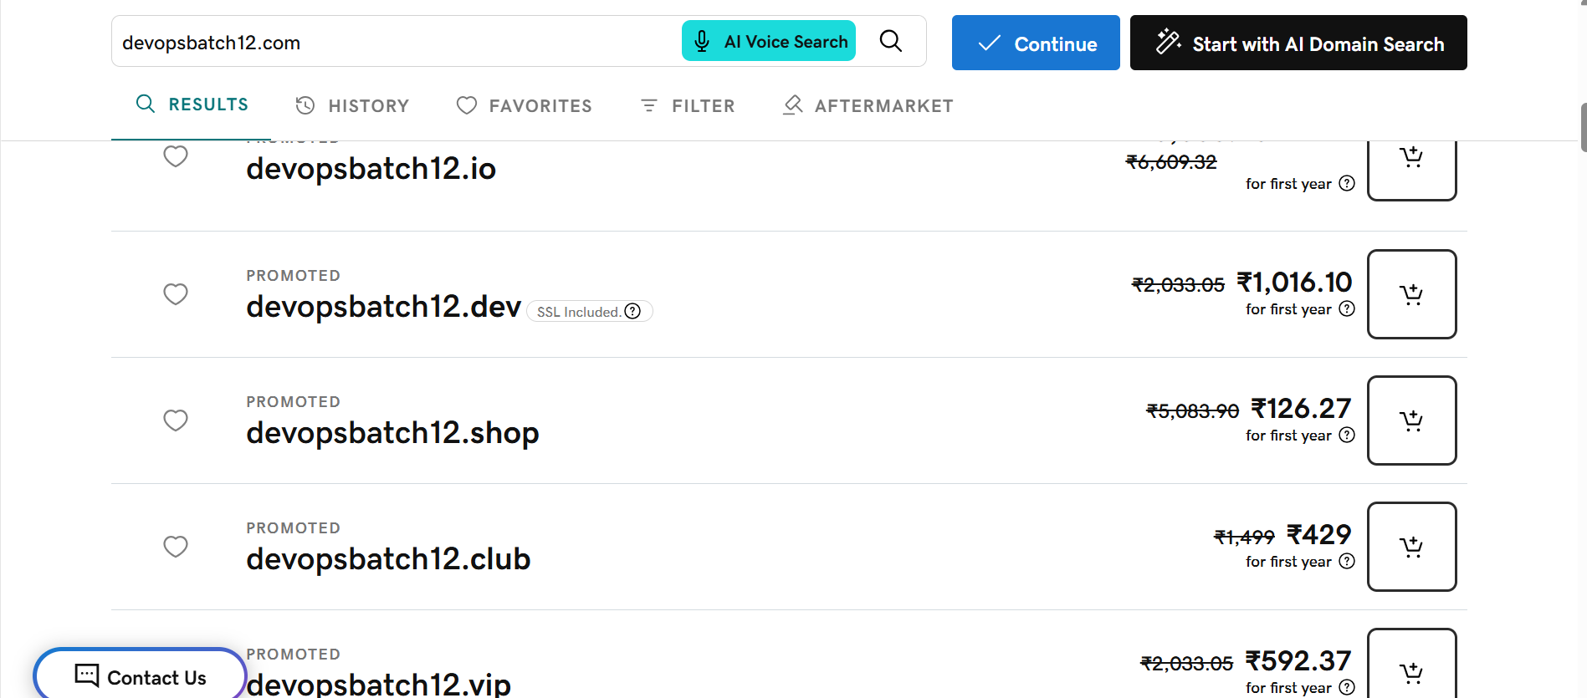

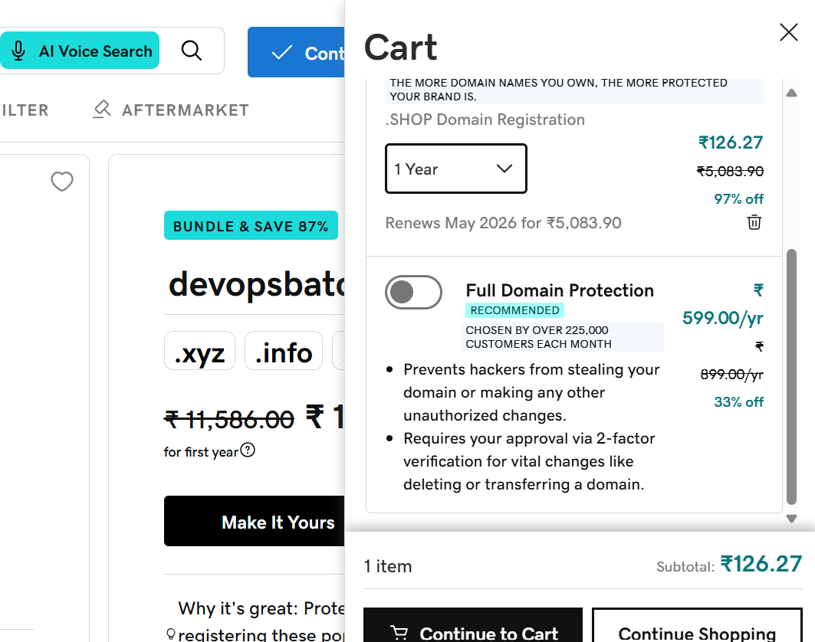

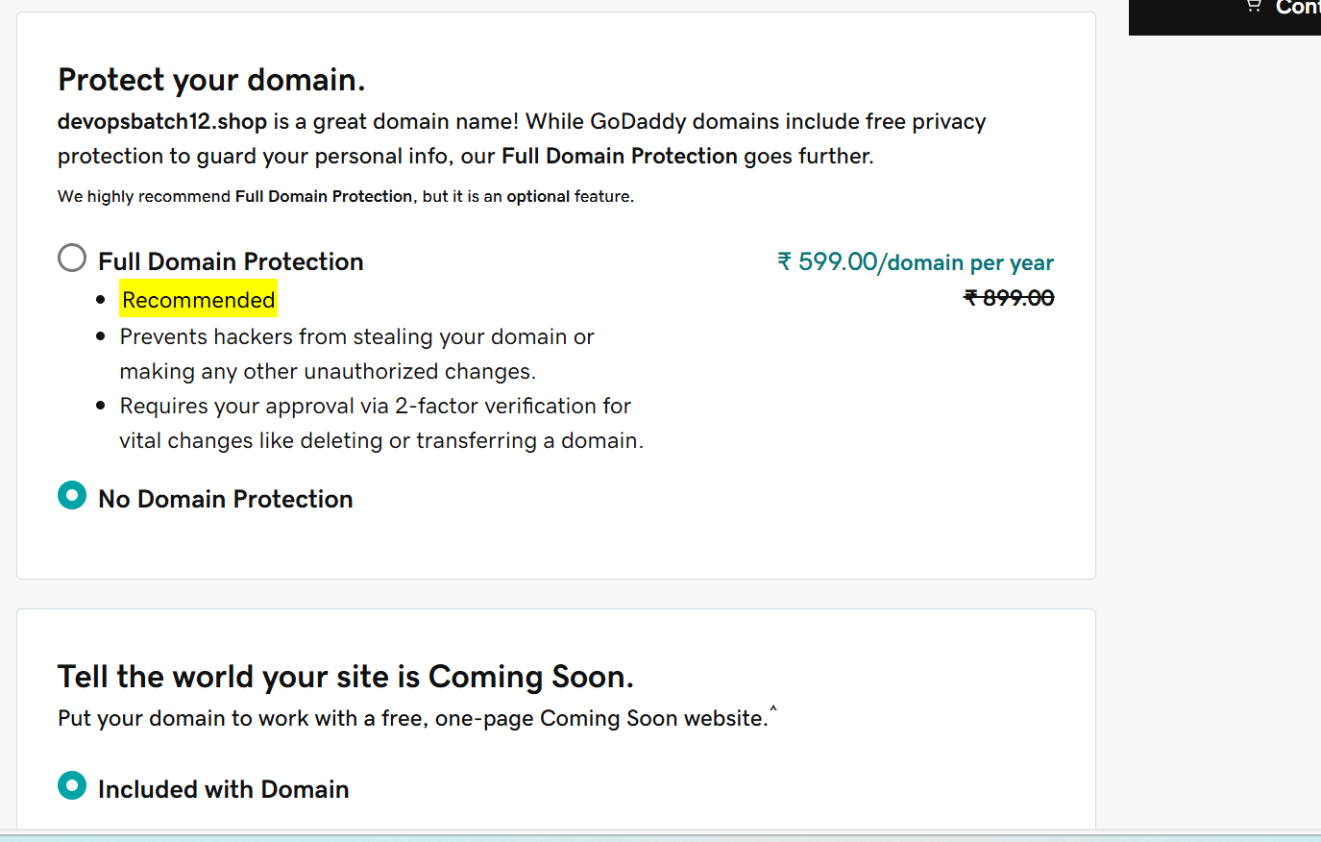

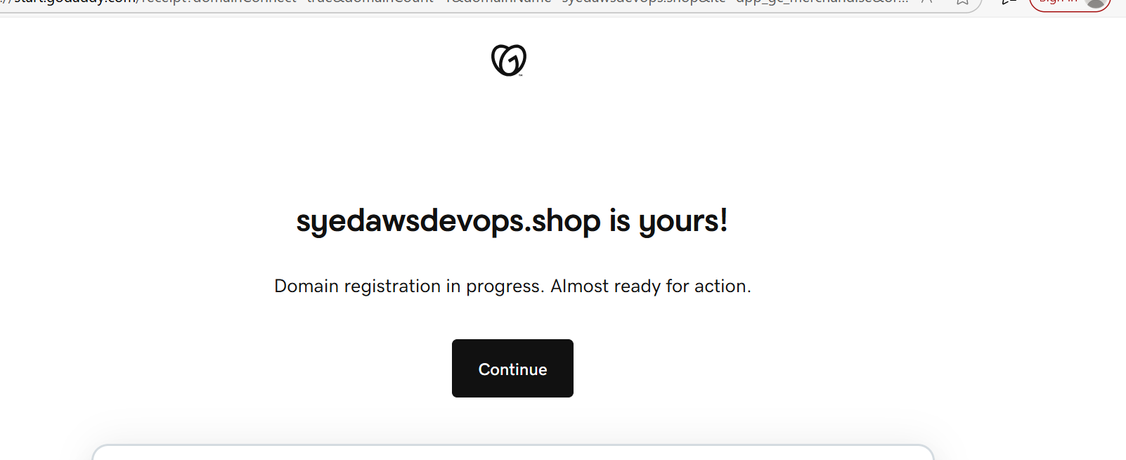

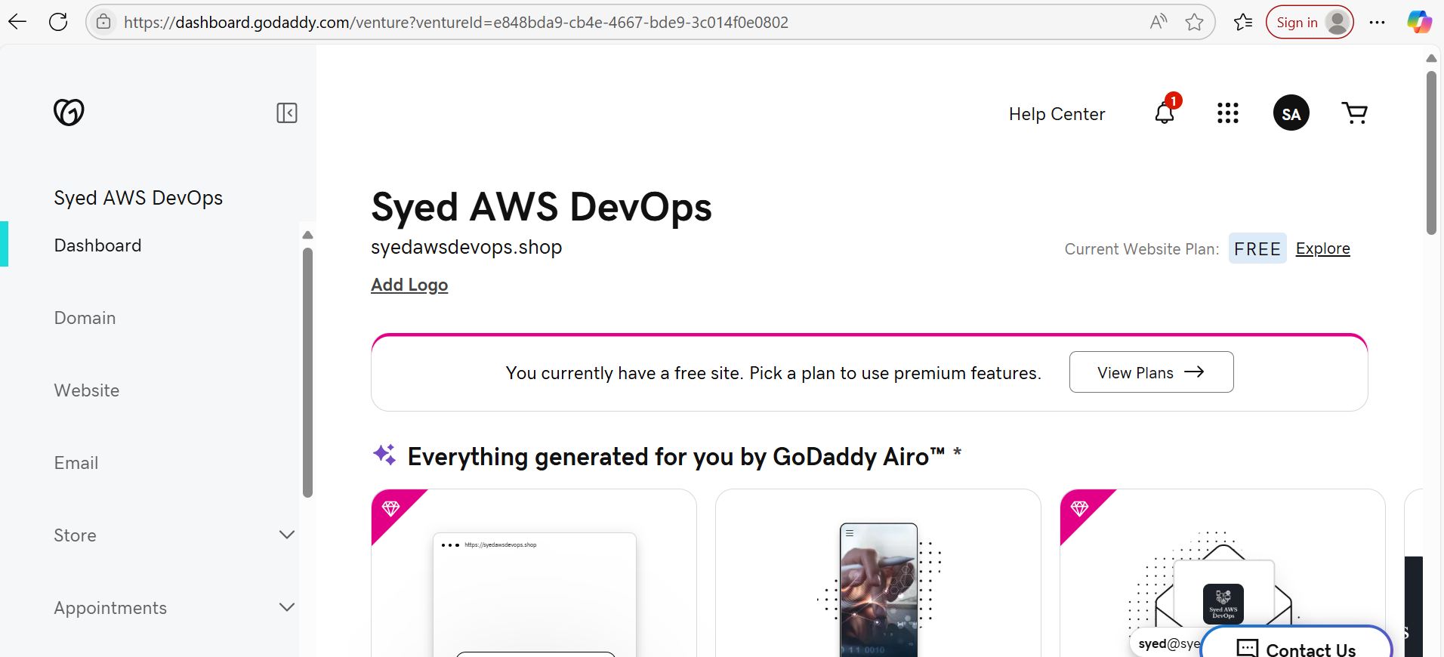

**3)** Deploy static website in s3

Create an S3 Bucket

- Log in to AWS Console → Go to S3.

- Click Create Bucket.

- Enter a unique bucket name (e.g., syedawsdevops.shop).

- Choose a Region (closer to your users for better performance).

- Disable Block Public Access (if you want public access).

- Click Create.

Enable Static Website Hosting

- Open your S3 bucket → Go to Properties.

- Scroll down to Static Website Hosting → Click Edit.

- Select Enable.

- Set the Index Document (e.g., index.html).

- Set the Error Document (optional, e.g., error.html).

- Click Save Changes.

Upload Website Files

- Open your S3 bucket → Go to Objects.

- Click Upload → Select your website files (index.html,error.html.).

- Click Upload and provide public access

Access Your Website

- Go to Properties → Static Website Hosting.

- Copy the Website Endpoint (e.g., http://syedawsdevops.shop.s3-website.eu-north-1.amazonaws.com/).

- Open it in your browser to verify the deployment.

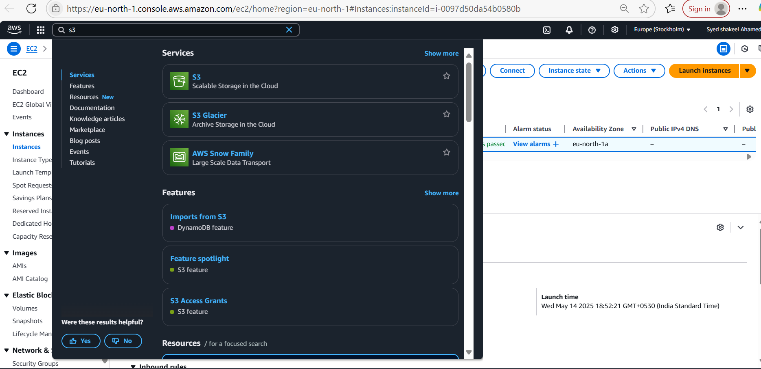

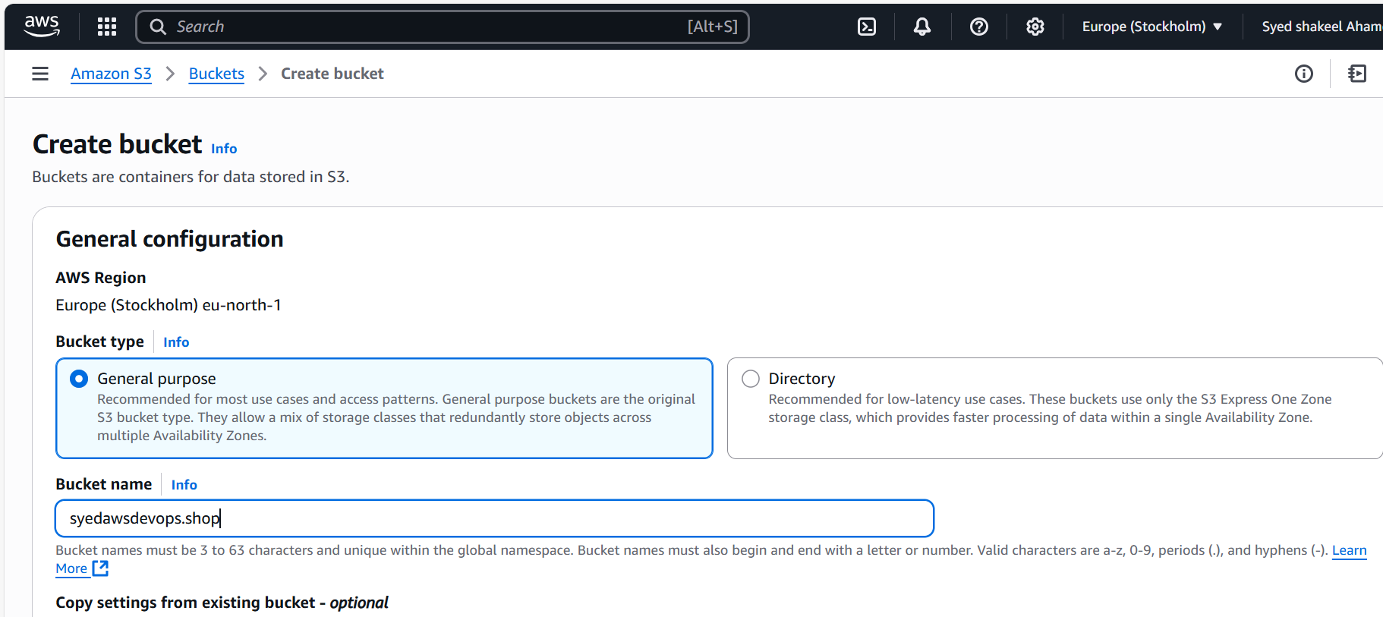

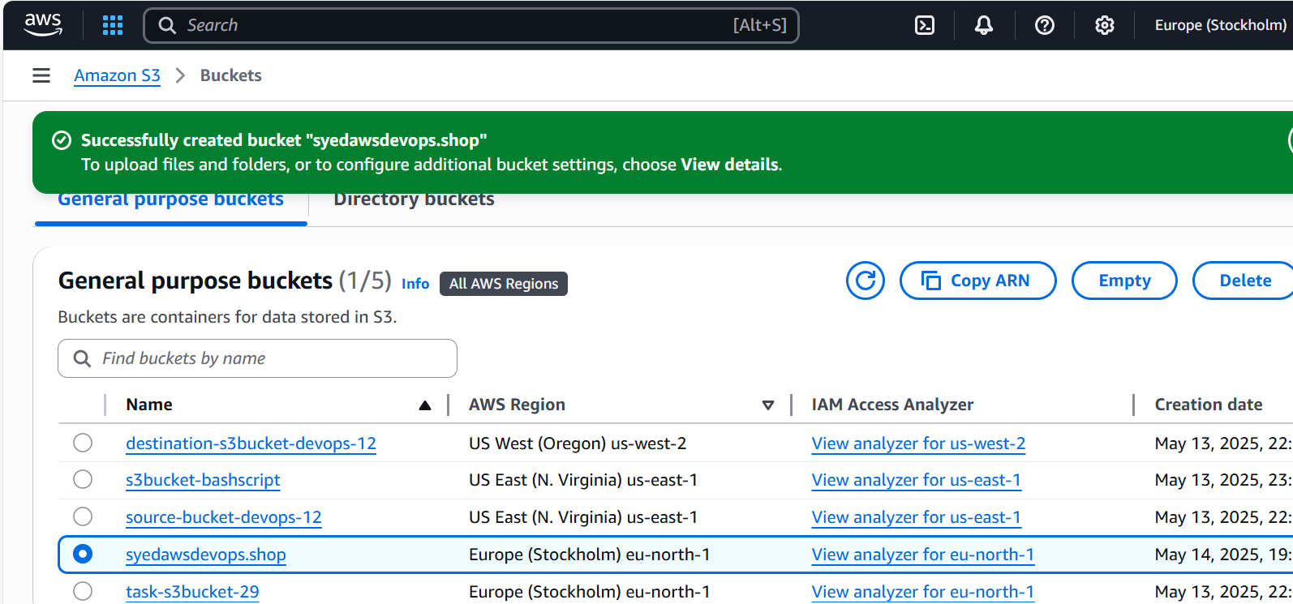

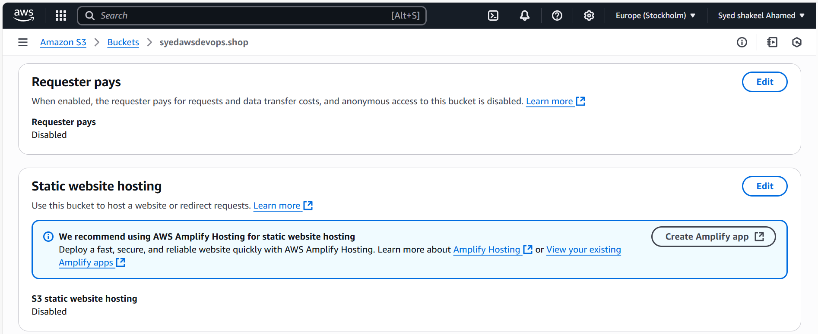

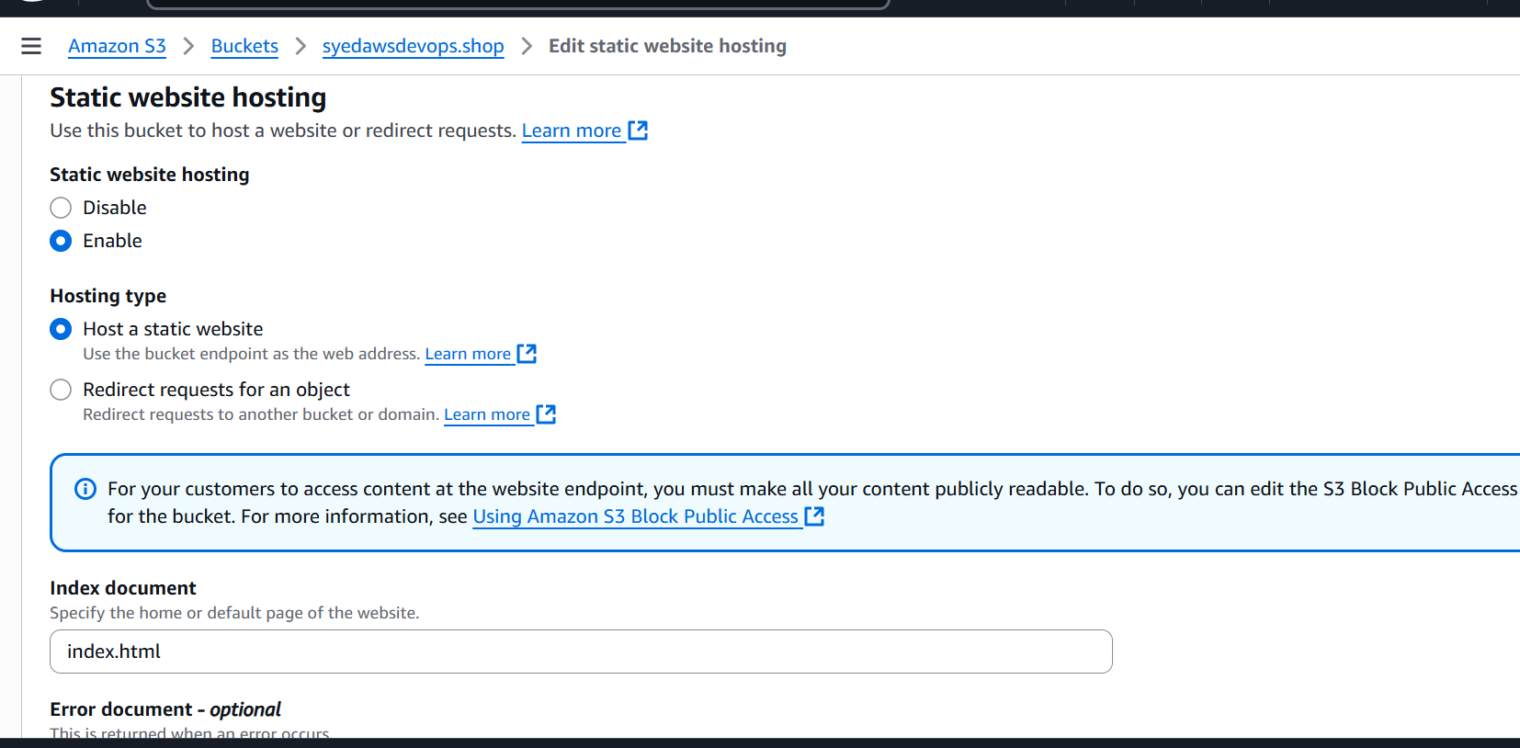

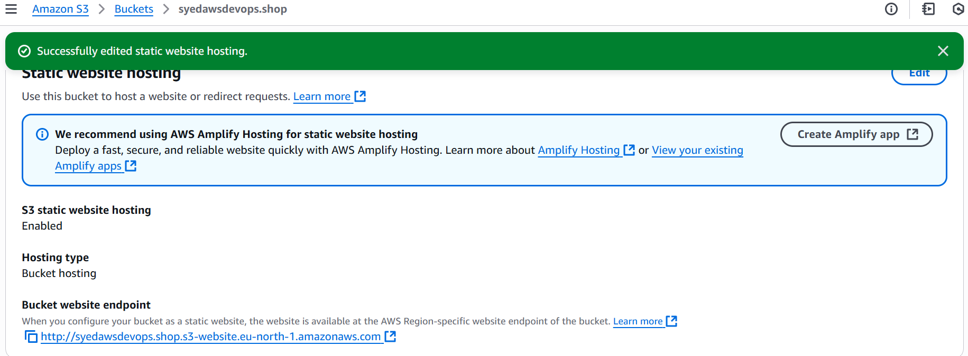

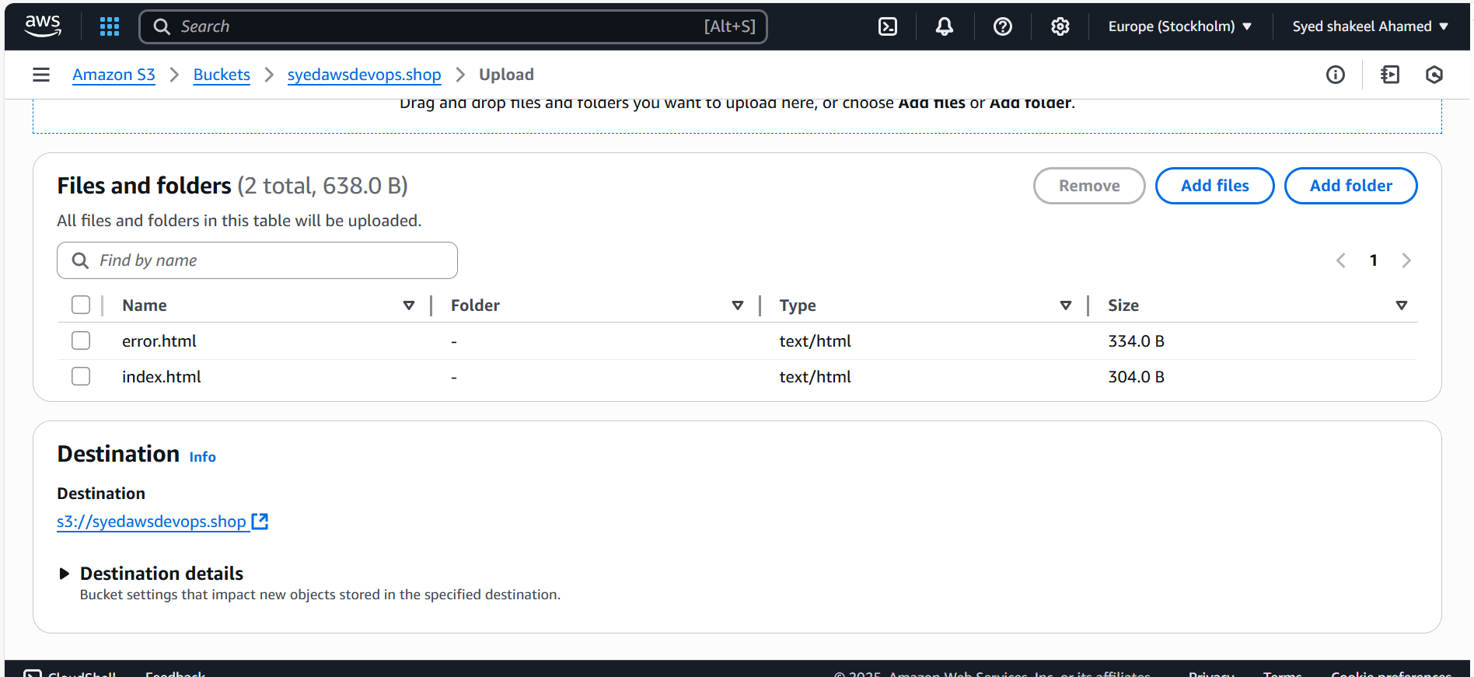

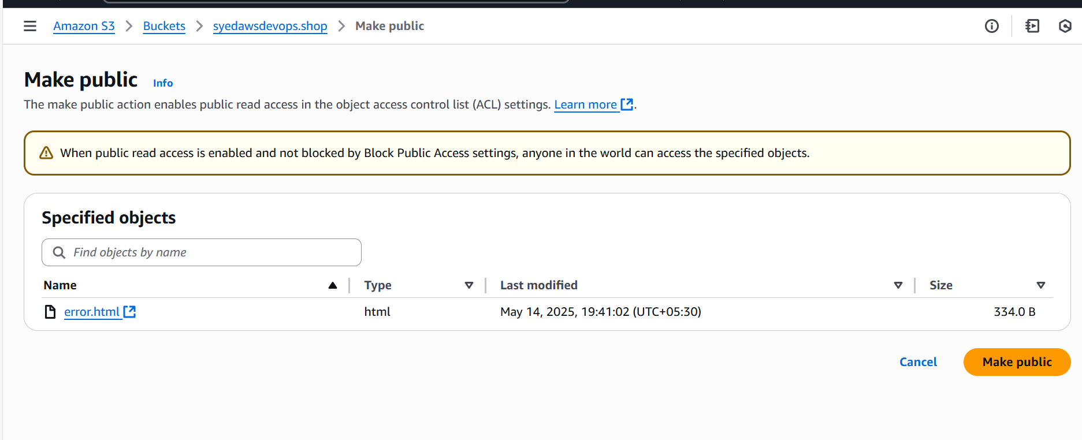

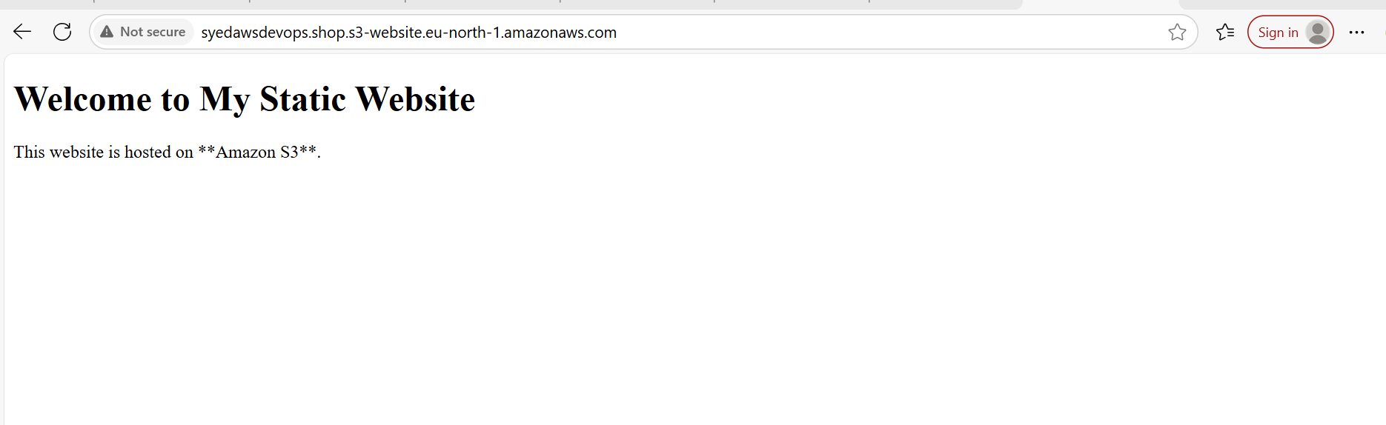

**4) Create CDN and attach one SSL certificate**

Create a CloudFront Distribution (CDN)

- Log in to AWS Console → Go to CloudFront.

- Click Create Distribution.

- Select Origin Domain Name (This could be your S3 bucket static website URL).

- Set Protocol to Redirect HTTP to HTTPS for SSL enforcement.

- Enable Caching (Choose based on your content delivery needs).

- Click Create → Wait for distribution deployment.

Step 2: Obtain an SSL Certificate

- Go to AWS Certificate Manager (ACM) → Request a Certificate.

- Choose Public Certificate → Enter your domain (syedawsdevops.shop).

- Select Validation Method:

- DNS Validation (Recommended): AWS provides a CNAME record.

- Email Validation (Alternative): Requires access to domain registrar email.

- Add the CNAME record to your DNS provider (Route 53, GoDaddy, etc.).

- Once validated, attach the SSL certificate to your CloudFront distribution.

Step 3: Attach SSL Certificate to CloudFront

- Go to CloudFront Console → Select your Distribution.

- Click Edit → Scroll to Custom SSL Certificate.

- Select the validated SSL certificate from ACM.

- Choose TLS version (Recommended: TLS 1.2 or 1.3).

- Click Save Changes.

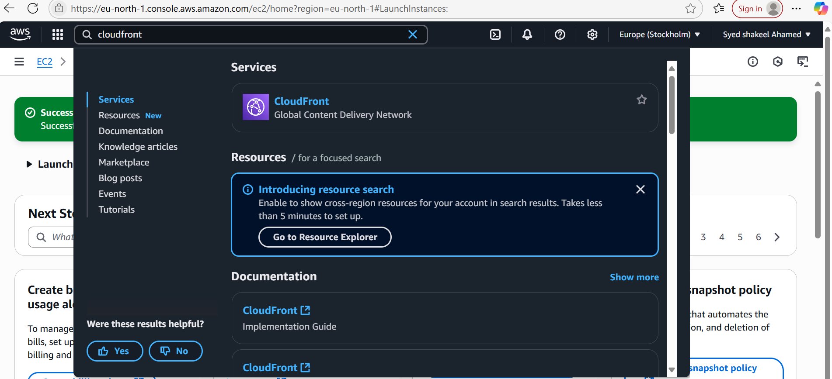

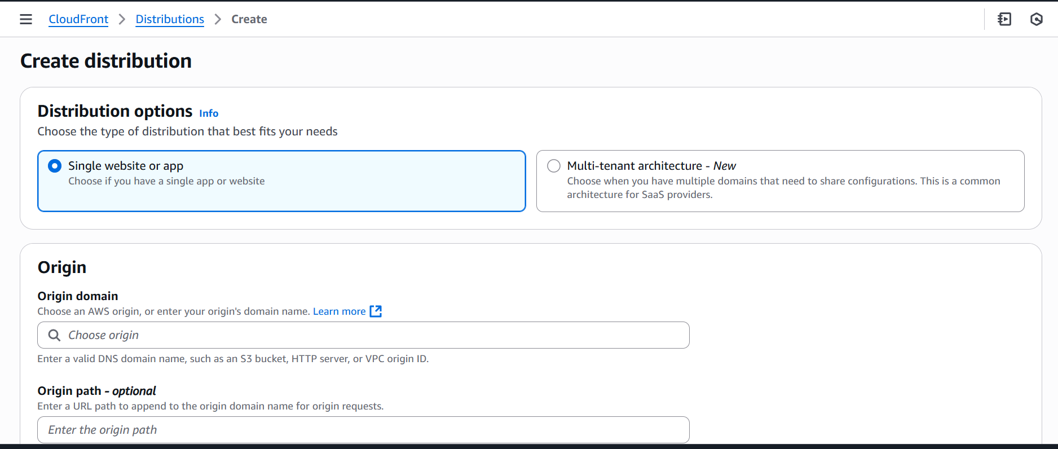

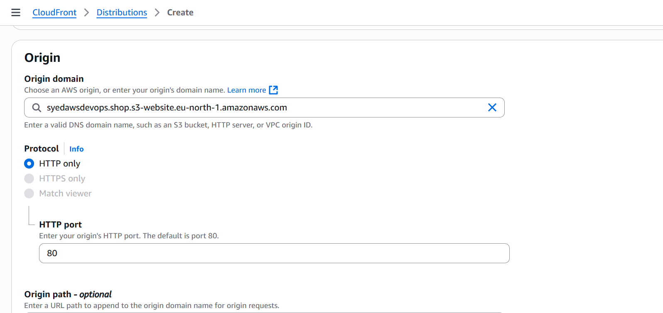

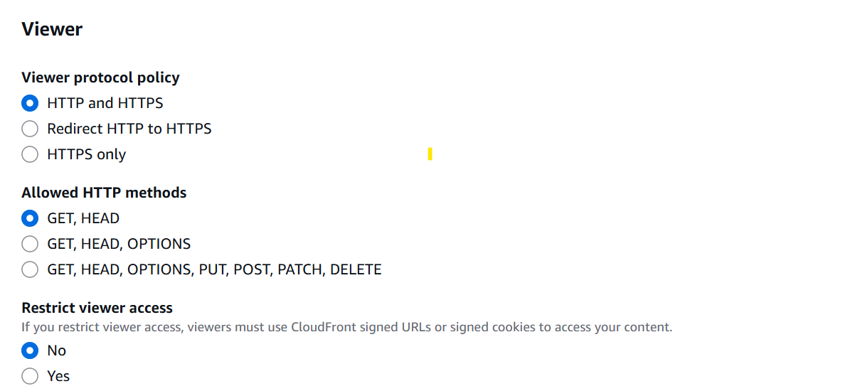

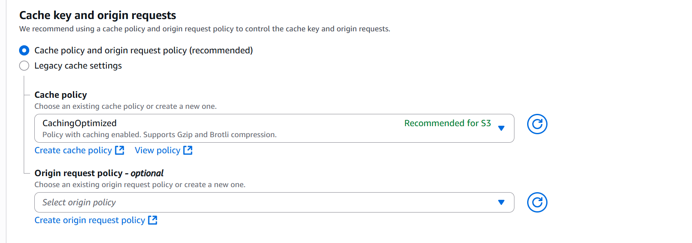

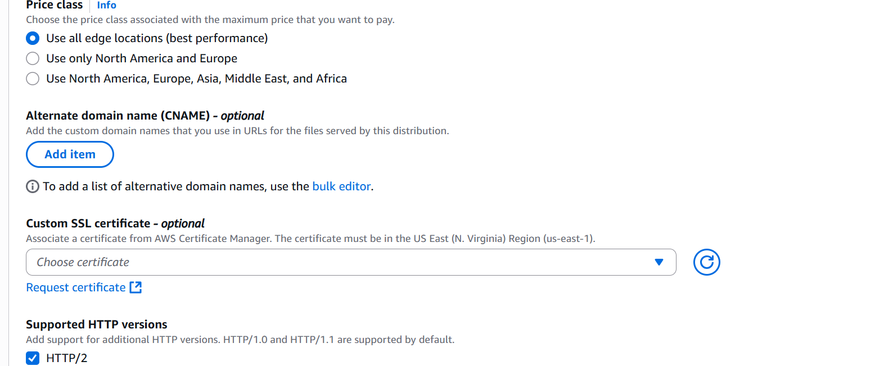

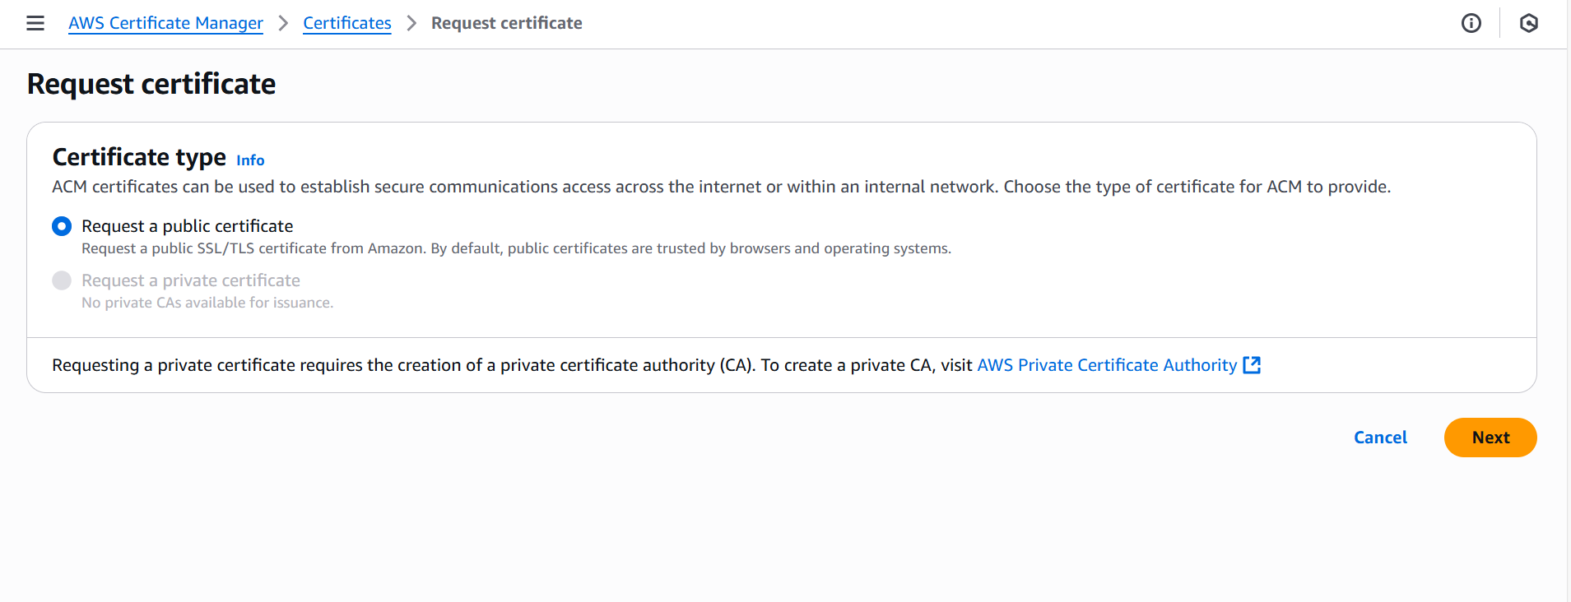

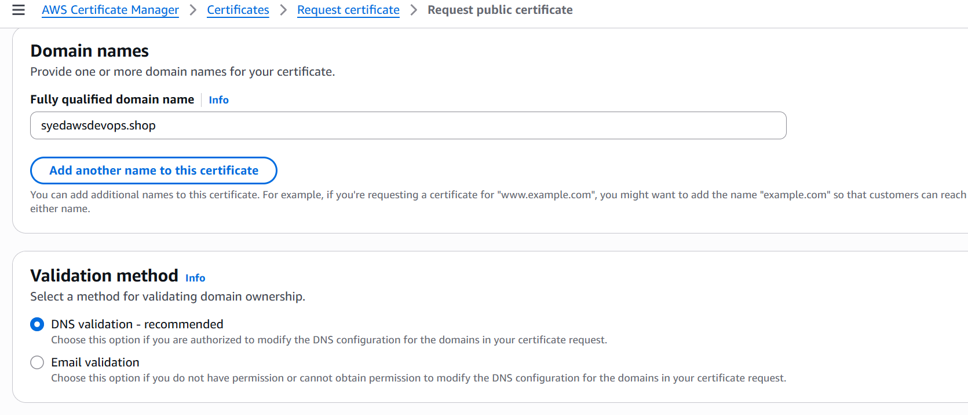

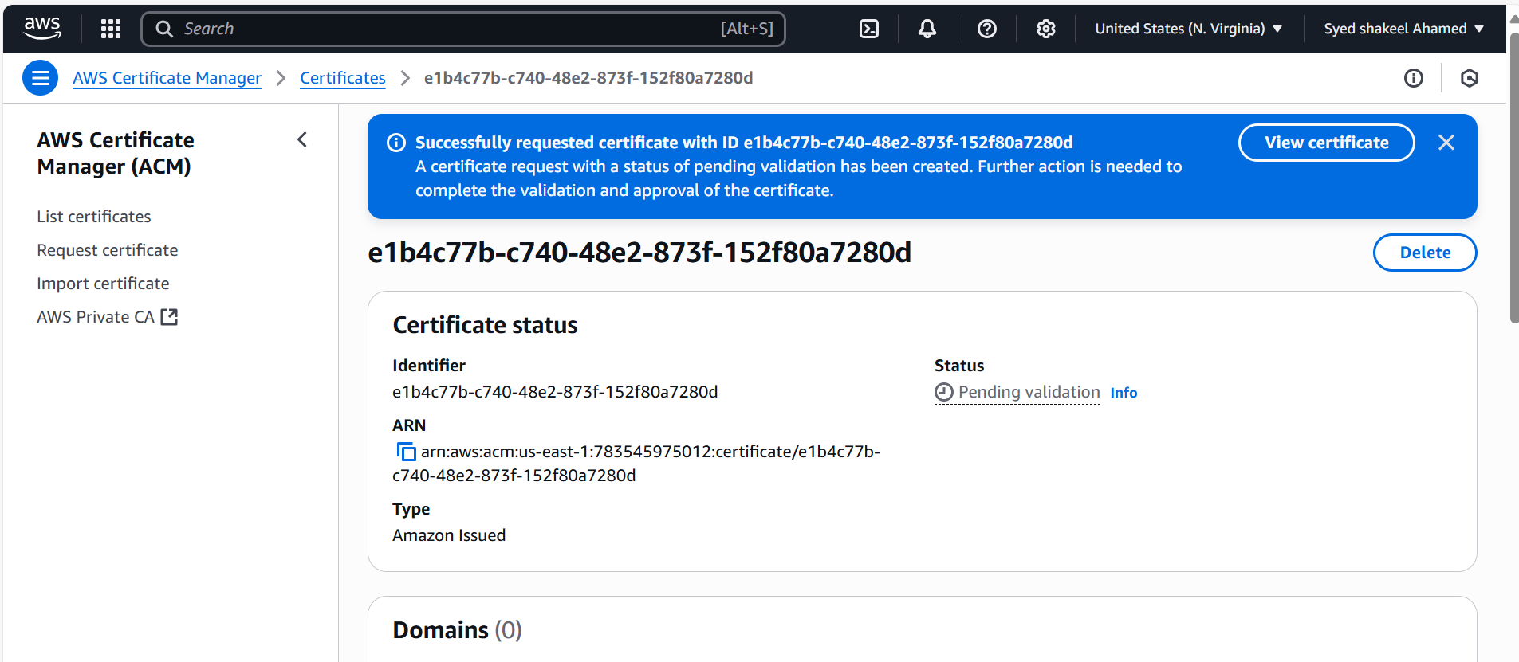

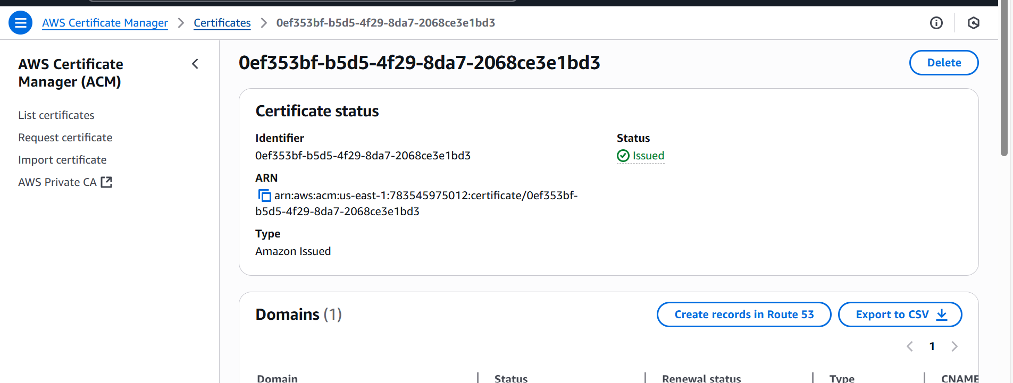

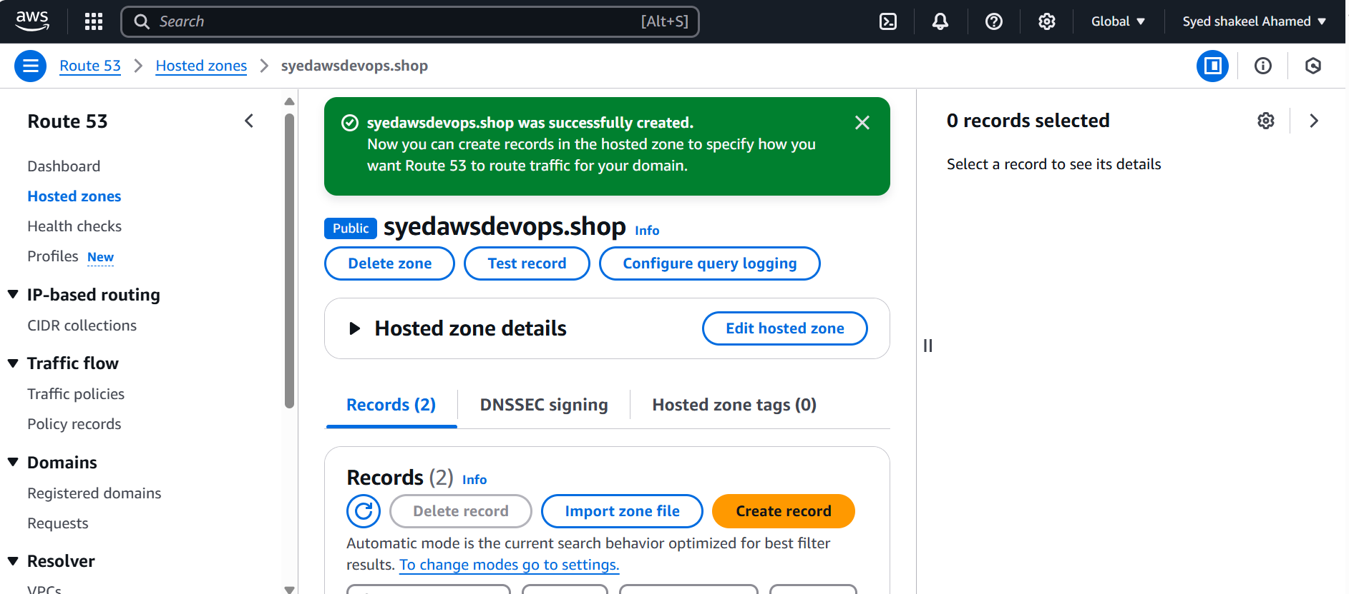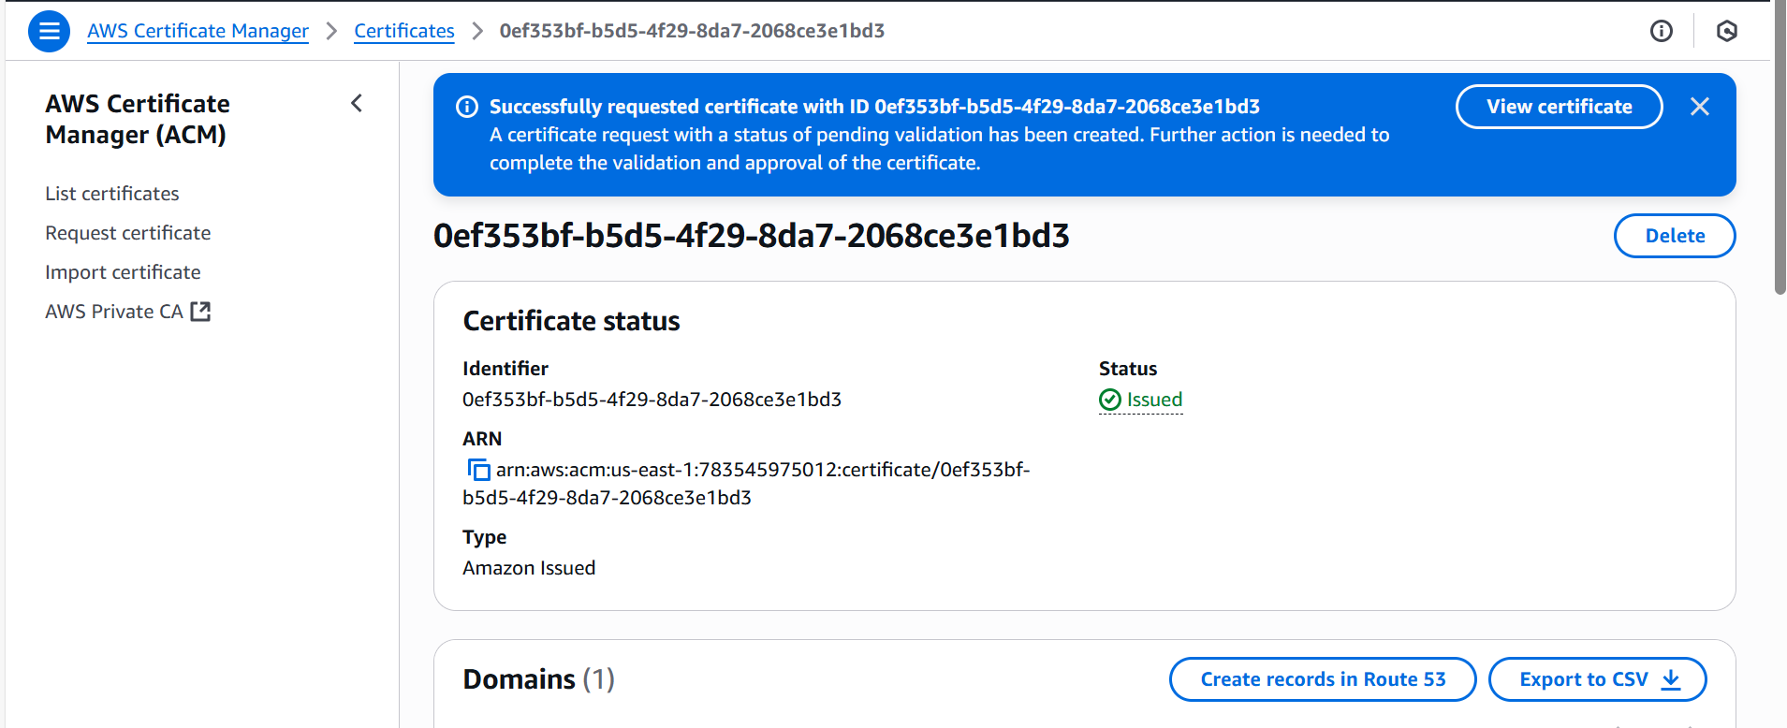

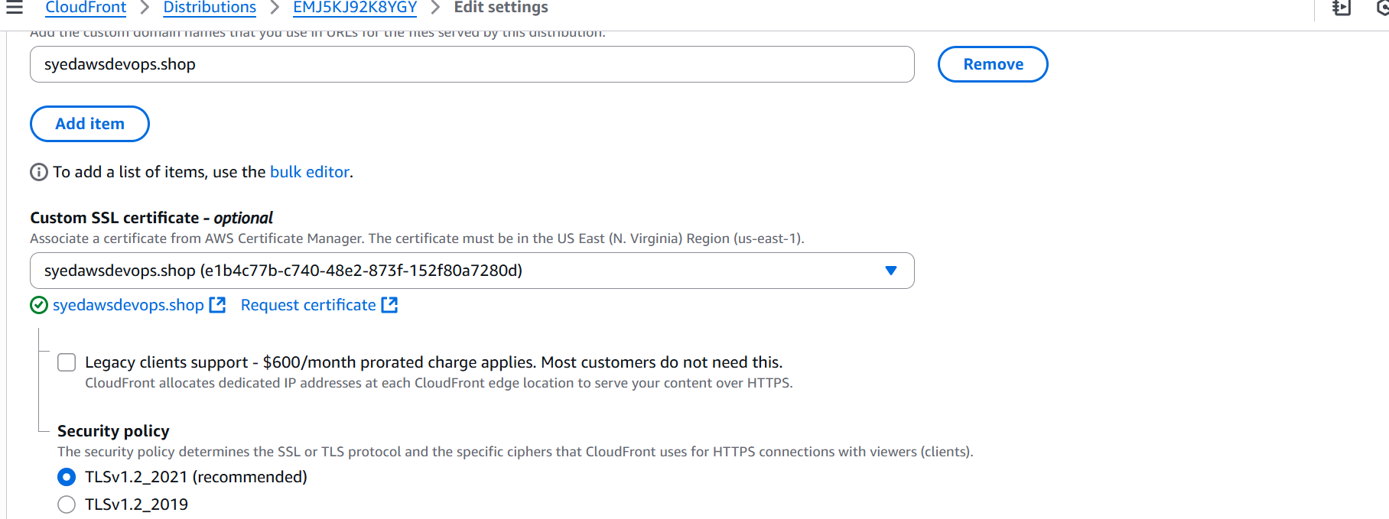

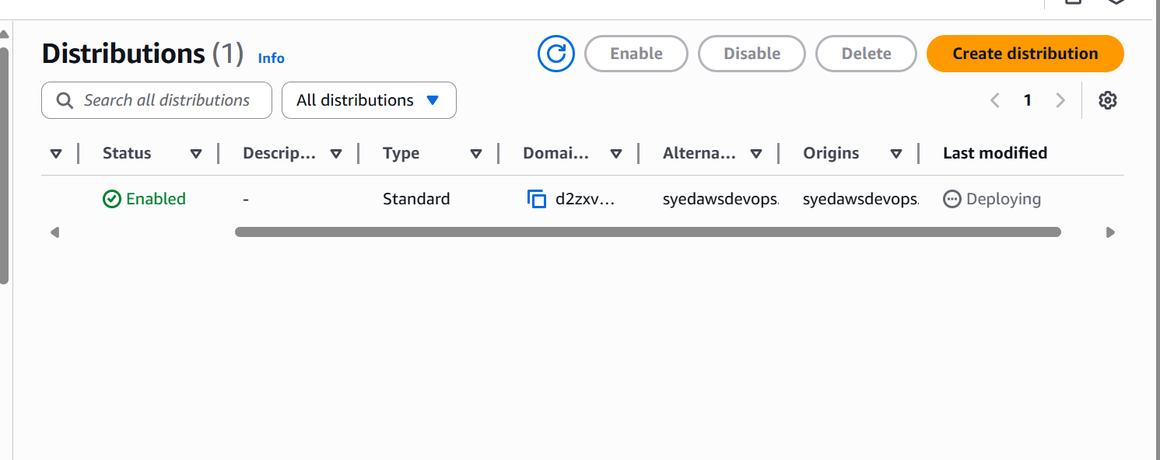

**5) Create Route53 hosted zone and MAP the domain with CDN**

Create a Route 53 Hosted Zone

- Log in to AWS Console → Go to Route 53.

- Click Hosted Zones → Create Hosted Zone.

- Enter your domain name (syedawsdevops.shop).

- Choose Public Hosted Zone (for internet-facing domains).

- Click Create.

- Note the NS (Name Server) records → Update them in your domain registrar (GoDaddy).

Step 2: Configure CloudFront CDN

- Go to AWS Console → CloudFront.

- Click Create Distribution.

- Select Origin Domain Name (e.g., your S3 bucket or ALB).

- Enable HTTPS and attach an SSL certificate (from AWS Certificate Manager).

- Click Create → Wait for deployment.

Step 3: Map Domain to CloudFront in Route 53

- Go to Route 53 → Select Hosted Zone.

- Create a new Alias Record:

- Record Type: A or CNAME

- Name: yourdomain.com

- Target: CloudFront distribution domain name (d2zxva60fbu5e6.cloudfront.net)

- Routing Policy: Simple

- Evaluate Target Health: No

-

Step 4: Verify Setup

- Open your browser and enter https://syedawsdevops.shop.

- If everything is configured correctly, your website should load via CloudFront.

Your domain is now mapped to CloudFront via Route 53! 🚀

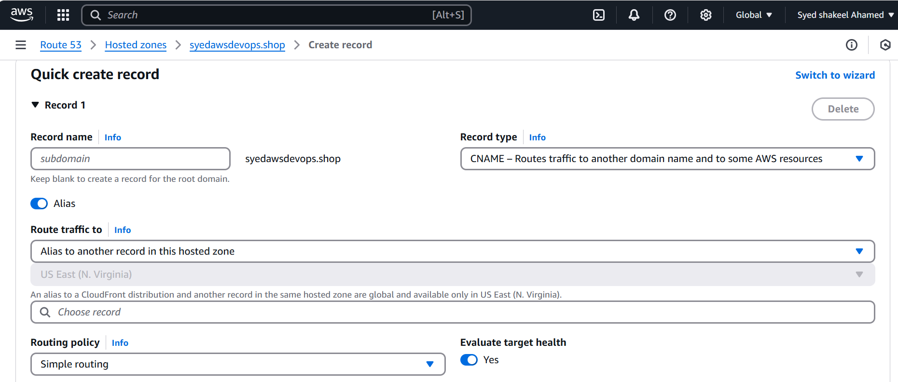

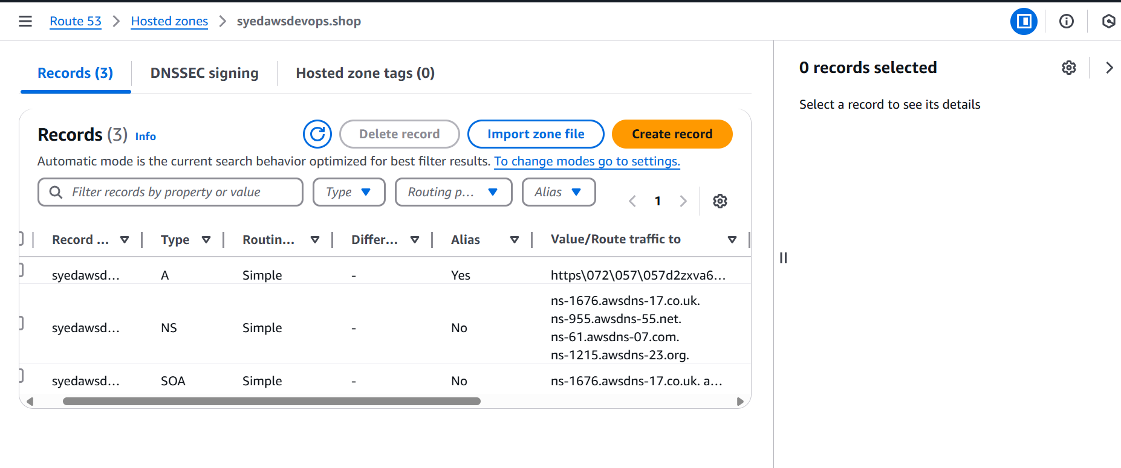

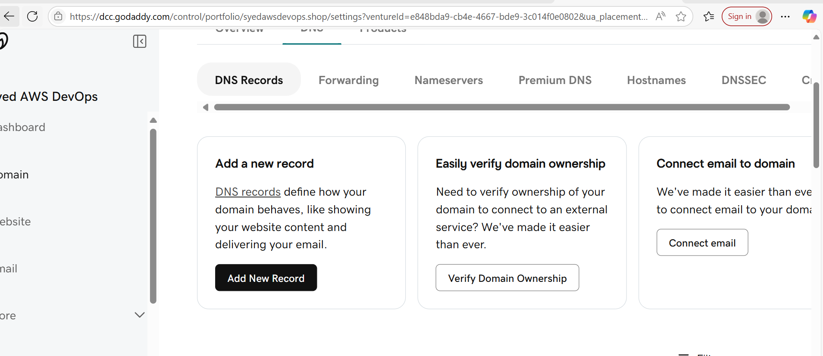

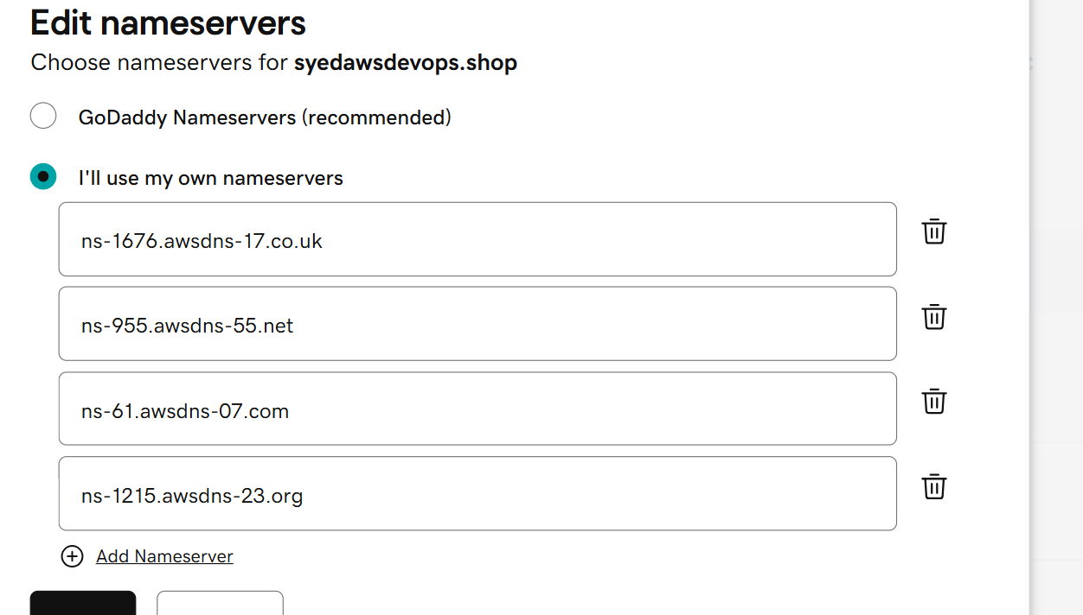

ns-1458.awsdns-54.org  
ns-705.awsdns-24.net  
ns-363.awsdns-45.com  
ns-1973.awsdns-54.co.uk

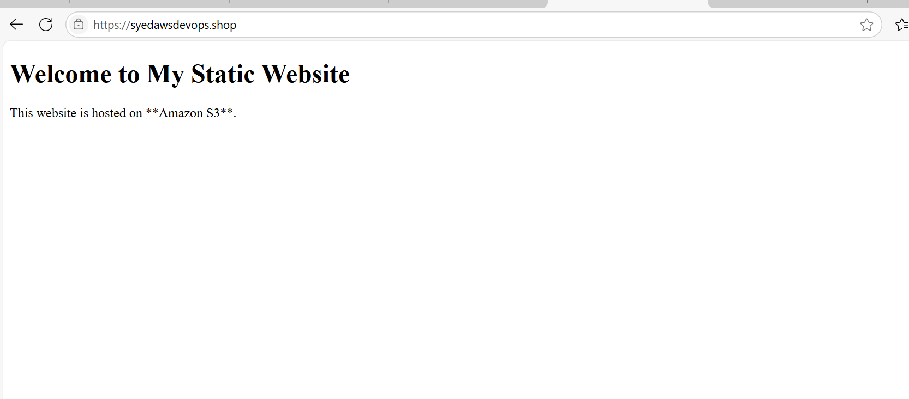

**6) Update the index.html in s3 bucket and the updated file should be accessible by using domain name.**

Upload the Updated index.html to S3

- Log in to AWS Console → Go to S3.

- Select your S3 bucket (e.g., my-static-site).

- Click Upload → Select the updated index.html file.

- Choose Replace existing file if prompted.

- Click Upload.

Clear CloudFront Cache (If Using CDN)

- Go to AWS CloudFront → Select your Distribution.

- Click Invalidations → Create Invalidation.

- Enter /* to clear all cached files.

- Click Invalidate → Wait for propagation.

Verify Domain Accessibility

- Open your browser and enter https://syedawsdevops.shop.

- If the old file still appears, try clearing your browser cache.

- Use DNS Checker to confirm DNS propagation.

Your updated index.html should now be accessible via your domain name

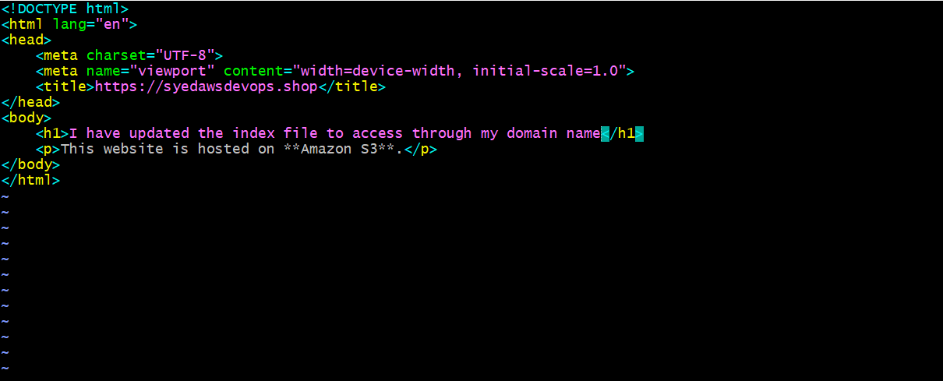

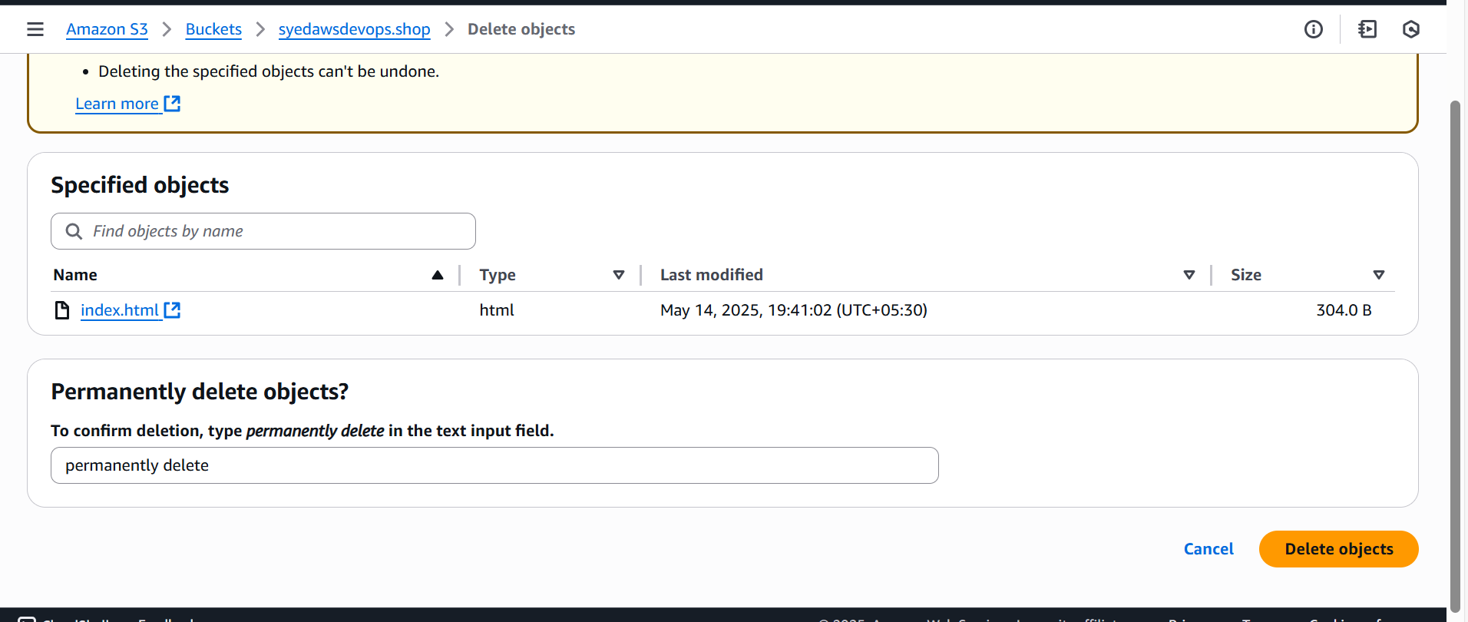

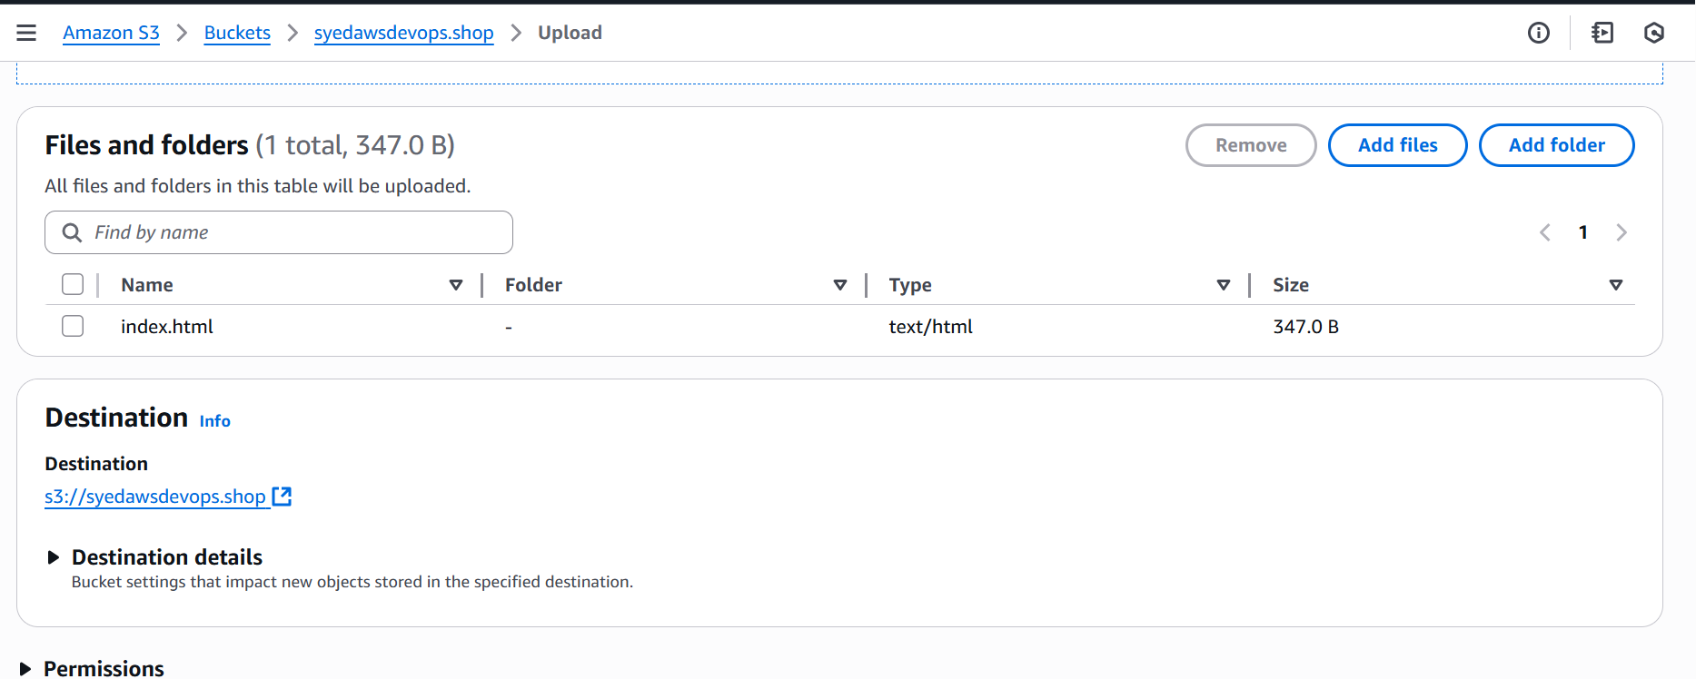

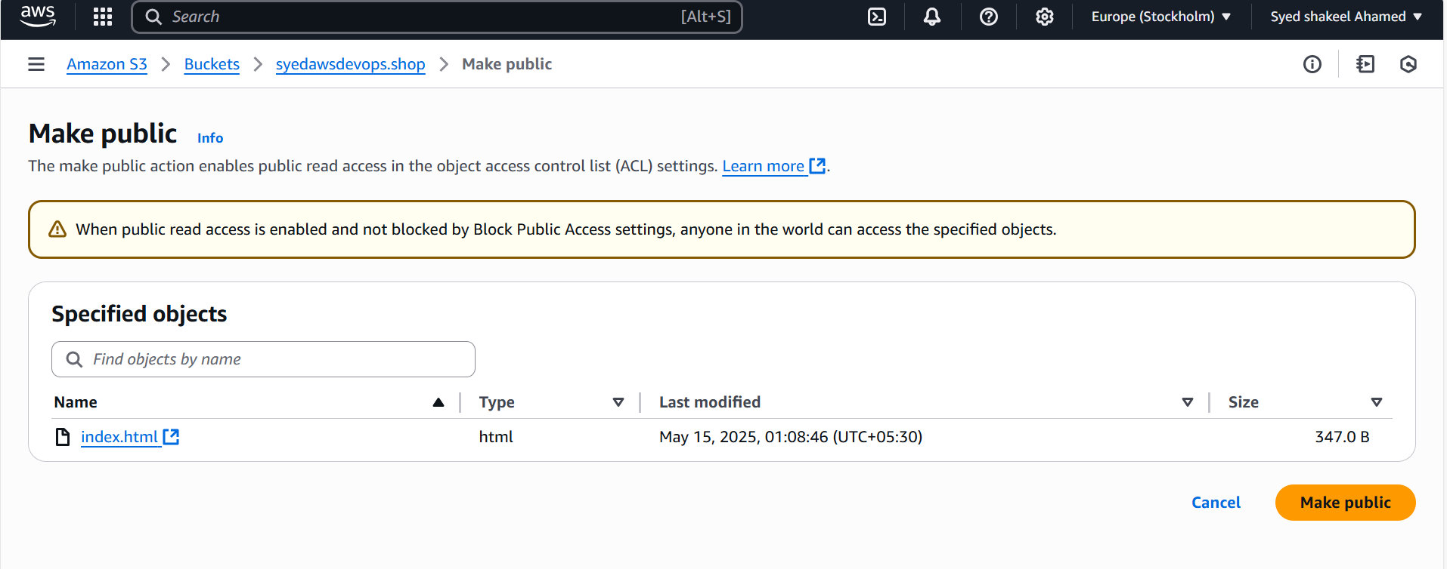

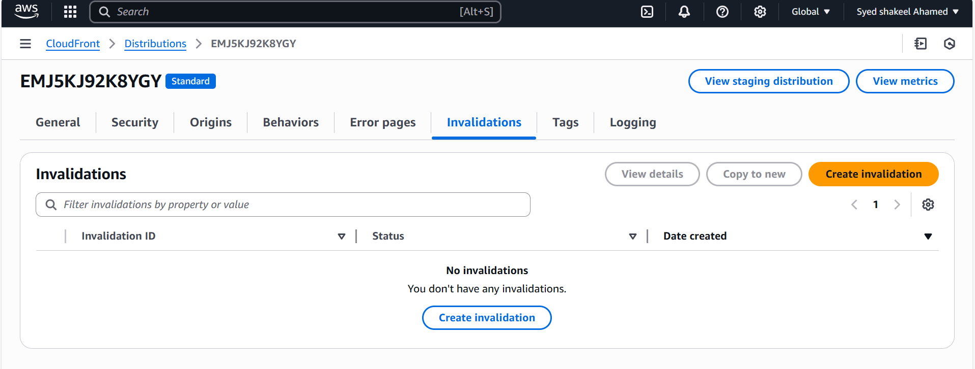

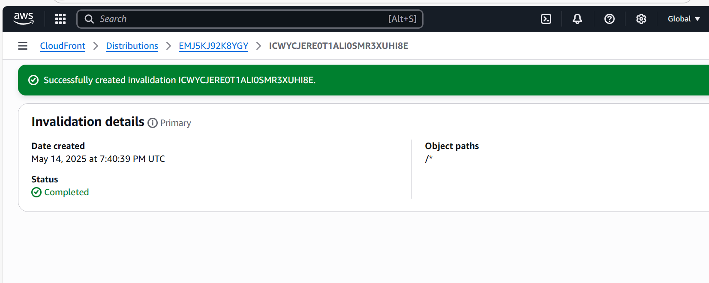

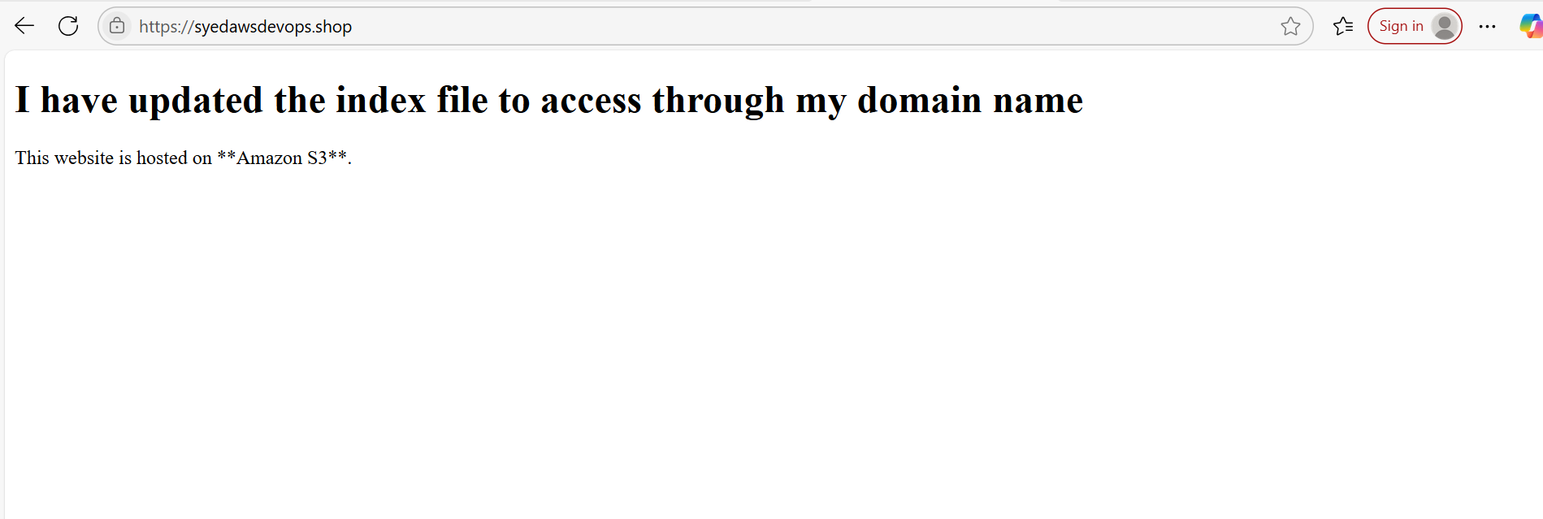

**7) Share the Domain name in slack to test the connectivity**

[https://syedawsdevops.shop](https://syedawsdevops.shop/)